**DETECTION OF OVARIAN CANCER USING MACHINE LEARNING ALGORITHMS**

## A PROJECT REPORT

***Submitted by,***

**Mr. MOHAMMED KASHIF - 20201CAI0162**

**Mr. SUJAY SASIKUMAR - 20201CAI0205**

**Mr. HARSITH S - 20201CAI0190**

**Mr. MANU KRISHNAN P M - 20201CAI0161**

**Mr. M NANDHA KUMAR - 20201CAI0160**

### *Under the guidance of,*

**Ms. DEVI**

***in partial fulfillment for the award of the degree of***

**BACHELOR OF TECHNOLOGY**

**IN**

**COMPUTER SCIENCE AND ENGINEERING**

**At**



**PRESIDENCY UNIVERSITY**

**BENGALURU**

**JANUARY 2024**

**PRESIDENCY UNIVERSITY**

**SCHOOL OF COMPUTER SCIENCE ENGINEERING & INFORMATION SCIENCE**

**CERTIFICATE**

This is to certify that the Project report **“DETECTION OF OVARIAN CANCER USING MACHINE LEARNING ALGORITHMS”** being submitted by “M NANDHA KUMAR, SUJAY SASIKUMAR, MOHAMMED KASHIF, HARSHITH S, MANU KRISHNAN P M” bearing roll number(s) “20201CAI0160, 20201CAI0205, 20201CAI0162, 20201CAI0190, 20201CAI0161” in partial fulfilment of requirement for the award of degree of Bachelor of Technology in Computer Science and Engineering(Artificial Intelligence and Machine Learning) is a bonafide work carried out under my supervision.

|  |  |
| --- | --- |
| **Ms. DEVI S**  Assistant Professor  School of CSE&IS  Presidency University | **Dr. ZAFAR ALI KHAN**  Associate Professor & HoD  School of CSE&IS  Presidency University |

|  |  |  |
| --- | --- | --- |
| **Dr. C. KALAIARASAN**  Associate Dean  School of CSE&IS  Presidency University | **Dr. SHAKKEERA L**  Associate Dean  School of CSE&IS  Presidency University | **Dr. SAMEERUDDIN KHAN** Dean  School of CSE&IS  Presidency University |

**PRESIDENCY UNIVERSITY**

**SCHOOL OF COMPUTER SCIENCE ENGINEERING & INFORMATION SCIENCE**

**DECLARATION**

We hereby declare that the work, which is being presented in the project report entitled **DETECTION OF OVARIAN CANCER USING MACHSINE LEARNING ALGORITHMS** in partial fulfilment for the award of Degree of **Bachelor of Technology** in **Computer Science and Engineering**, is a record of our own investigations carried under the guidance of **DEVI S, ASSISTANT PROFESSOR,** **School of Computer Science Engineering & Information Science, Presidency University, Bengaluru.**

We have not submitted the matter presented in this report anywhere for the award of any other Degree.

|  |  |
| --- | --- |
|  | **M NANDHA KUMAR (20201CAI0160)**  **SUJAY SASIKUMAR (20201CAI0205)**  **MOHAMMED KASHIF (20201CAI0162)**  **HARSHITH S (20201CAI0190)**  **MANU KRISHNAN P M (20201CAI0161)** |

**ABSTRACT**

This research paper addresses the critical issue of early detection in ovarian cancer through the application of machine learning (ML) algorithms. Late-stage diagnoses in ovarian cancer often pose significant challenges, emphasizing the urgent need for innovative solutions. Leveraging a comprehensive dataset incorporating clinical and genetic features, the materials and methods section outlines a meticulous approach to data preprocessing and the implementation of diverse ML algorithms, including Logistic Regression, Random Forest, Support Vector Machines, and Neural Networks.

The results showcase promising outcomes, with each algorithm demonstrating distinct strengths in ovarian cancer detection. Rigorous evaluation metrics, including accuracy, precision, recall, and F1 score, ensure a comprehensive and robust assessment of model performance. These metrics collectively contribute to a nuanced understanding of the algorithms' capabilities and limitations in the context of early ovarian cancer detection.

The discussion section delves into the implications of the results, addressing challenges such as data imbalances and interpretability issues that are inherent in healthcare datasets. Model interpretability techniques are employed to provide a deeper understanding of the predictive factors driving the algorithms' decisions. This not only enhances the trustworthiness of the models but also contributes valuable insights for medical practitioners.

In looking towards the future, the report emphasizes the importance of ongoing research to further enhance ovarian cancer detection models. The discussion on future directions underscores the continuous need for improvement and adaptation as new data becomes available and as ML techniques evolve. This forward-looking perspective positions the research within the broader landscape of advancements in cancer diagnostics.

In conclusion, this paper underscores the substantial potential of ML algorithms in improving early ovarian cancer detection. The comprehensive evaluation, coupled with interpretability analyses, enhances the robustness of findings, serving as a valuable foundation for future advancements in innovative cancer diagnosis methodologies. Ultimately, the integration of machine learning into ovarian cancer detection holds promise for significantly improving patient outcomes through early intervention.

**ACKNOWLEDGEMENT**

First of all, we indebted to the **GOD ALMIGHTY** for giving me an opportunity to excel in our efforts to complete this project on time.

We express our sincere thanks to our respected dean **Dr. Md. Sameeruddin Khan**, Dean, School of Computer Science and Engineering and School of Information Science, Presidency University for getting us permission to undergo the project.

We record our heartfelt gratitude to our beloved Associate Deans **Dr. Kalaiarasan C** and **Dr. Shakkeera L**, School of Computer Science and Engineering and School of Information Science, Presidency University and **Dr. Zafar Ali Khan**, Head of the Department, School of Computer Science and Engineering, Presidency University for rendering timely help for the successful completion of this project.

We are greatly indebted to our guide **Ms Devi S**, Assistant Professor, School of Computer Science and Engineering, Presidency University for her inspirational guidance, and valuable suggestions and for providing us a chance to express our technical capabilities in every respect for the completion of the project work.

We would like to convey our gratitude and heartfelt thanks to the University Project-II Coordinators **Dr. Sanjeev P Kaulgud, Dr. Mrutyunjaya MS** and the department Project Coordinator **Dr Murali Parameswaran**.

We thank our family and friends for the strong support and inspiration they have provided us in bringing out this project

**M NANDHA KUMAR**

**SUJAY SASIKUMAR**

**MOHAMMED KASHIF**

**HARSHITH S**

**MANU KRISHNAN P M**

**LIST OF TABLES**

|  |  |  |  |
| --- | --- | --- | --- |
| **Sl. No.** | **Table Name** | **Table Caption** | **Page No.** |
| 1 | Table 9.1 | Accuracy of all the machine learning algorithms | 45 |

**LIST OF FIGURES**

|  |  |  |  |
| --- | --- | --- | --- |
| **Sl. No.** | **Figure Name** | **Caption** | **Page No.** |
| 1  2  3  4  5 | Figure 1.1  Figure 4.1  Figure 5.1  Figure 7.1  Figure 9.1 | Ovarian Cancer Age-wise Analytics  Proposed Method Workflow  Objectives  Timeline Gantt Chart  Accuracy of all the machine learning algorithms | 2  12  19  42  46 |

**TABLE OF CONTENTS**

|  |  |  |
| --- | --- | --- |
| **CHAPTER NO.** | **TITLE** | **PAGE NO.** |
|  | **ABSTRACT ACKNOWLEDGMENT**  **…** | **i**  **ii**  **…** |
| **1.** | **INTRODUCTION** | 1 |
|  | * 1. Ovarian Cancer      1. Understanding Ovarian Cancer      2. Causes of Ovarian Cancer      3. Importance of early detection | 1 |
|  | * 1. Machine Learning algorithm in early detection | 3 |
| **2.** | **LITERATURE REVIEW** | 5 |

### 3. RESEARCH GAPS OF EXISTING METHODS 10

### 4. PROPOSED METHODOLOGY 12

### 5. OBJECTIVES 19

**6. SYSTEM DESIGN & IMPLEMENTATION** 21

**7. TIMELINE FOR EXECUTION OF PROJECT**  40

**8. OUTCOMES** 42

**9. RESULTS AND DISCUSSIONS** 44

**10. CONCLUSION** 47

**11. REFERENCES**

**12. APPENDIX-A**

**CHAPTER-1**

**INTRODUCTION**

* 1. **Ovarian Cancer**
     1. **Understanding Ovarian Cancer**

Ovarian cancer stands as a formidable and often undetected adversary, impacting the ovaries, essential reproductive organs responsible for egg production and female hormone regulation. Ranking among the most lethal gynecological cancers, ovarian cancer presents a significant health challenge, particularly due to its asymptomatic nature in the early stages and the absence of reliable screening methods.

The genesis of ovarian cancer occurs when abnormal cells within the ovaries undergo uncontrolled proliferation, forming tumors that may either be non-cancerous or malignant with the potential to metastasize. While various types of ovarian cancer exist, the majority of cases involve epithelial ovarian carcinomas, originating from cells covering the ovary's surface.

Ovarian cancer poses a noteworthy health risk, with women facing a 1 in 78 likelihood of developing the disease in their lifetime. The gravity of the situation becomes even more pronounced when considering the lifetime risk of succumbing to invasive ovarian cancer, standing at 1 in 108. Regrettably, survival rates for ovarian cancer trail behind those of other women's cancers, with a relative five-year survival rate of a modest 49.7%. Notably, the linchpin for improved outcomes lies in early detection. Women diagnosed in the early stages, prior to cancer spread, experience significantly higher five-year survival rates compared to later-stage diagnoses. However, the alarming statistic that only about 17% of ovarian cancer patients receive early-stage diagnoses underscores the critical imperative for heightened screening, awareness, and early intervention measures in tackling this formidable health challenge.

* + 1. **Causes of Ovarian Cancer**

Ovarian cancer, a complex and often aggressive disease, arises due to the uncontrolled growth of abnormal cells in the ovaries. The exact causes of ovarian cancer are not fully understood, but several risk factors have been identified that may contribute to its development. The main reasons are:

A. Age:

Advanced age is a significant risk factor for ovarian cancer. The majority of ovarian cancer cases occur in women over the age of 50, with the highest incidence observed in those over 63.

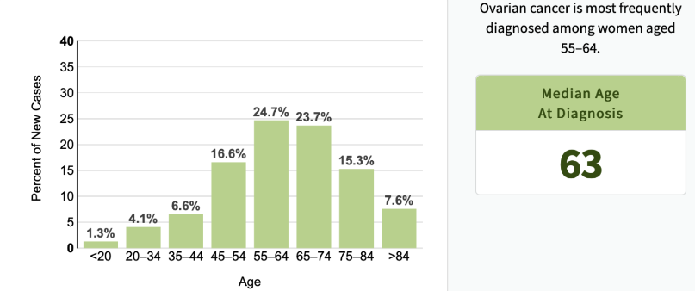

Figure 1.1 Ovarian Cancer Age-wise Analytics

B. Family History and Genetic Factors:

A family history of ovarian, breast, or colorectal cancers increases the risk of ovarian cancer. Inherited mutations in certain genes, such as BRCA1 and BRCA2, are associated with a higher likelihood of developing ovarian cancer. These genetic mutations can be passed down from one generation to the other and this happens generations to generations.

C. Hormonal Factors:

Reproductive and hormonal factors play a role in ovarian cancer risk. Women who started menstruating early or experienced late menopause face a slightly higher risk. Additionally, factors such as never having been pregnant or undergoing fertility treatments may contribute to an increased risk.

D. Personal History of Cancer:

Women with a history of breast, colorectal, or endometrial cancer may have an elevated risk of developing ovarian cancer.

E. Environmental and Lifestyle Factors:

While the evidence is not conclusive, factors such as obesity, hormone replacement therapy (HRT), and the use of talcum powder in the genital area have been studied for potential associations with an increased risk of ovarian cancer.

Understanding these risk factors is really important for early detection and implementing preventive measures. Regular health check-ups, genetic counseling for at-risk individuals, and lifestyle modifications can contribute to the early identification and management of ovarian cancer, ultimately improving outcomes for affected individuals.

* + 1. **The Importance of Early Detection**

Early detection of ovarian cancer is at most important for several reasons. Firstly, the symptoms of ovarian cancer are often vague and nonspecific, leading to delayed diagnosis. By the time symptoms manifest, the disease may have advanced to later stages, significantly impacting treatment outcomes. Secondly, ovarian cancer lacks a routine and effective screening method, making early detection through symptom recognition and diagnostic tests crucial.

Early detection can substantially improve the prognosis and overall survival rates of individuals diagnosed with ovarian cancer. In the early stages, when the disease is confined to the ovaries, the likelihood of successful treatment is higher. Timely intervention enables healthcare professionals to employ less aggressive treatment modalities and increases the chances of complete tumor removal.

Furthermore, early detection allows for more targeted and effective treatment strategies, potentially sparing patients from the side effects associated with more aggressive interventions. This underscores the critical role of awareness, regular health check-ups, and proactive screening in identifying ovarian cancer at its incipient stages.

In conclusion, ovarian cancer is a complex and challenging disease with elusive causes, making early detection imperative for positive patient outcomes. Understanding the significance of recognizing risk factors, monitoring symptoms, and advocating for early screening measures is vital in the collective effort to combat ovarian cancer and improve the chances of successful treatment. As research progresses, advancements in early detection methods offer hope in the ongoing fight against this insidious disease.

* 1. **Machine Learning Algorithm in early detection of Ovarian cancer**

Detection using machine learning (ML) algorithms holds immense promise in revolutionizing the early diagnosis of ovarian cancer, offering several advantages that contribute to improved outcomes for patients:

1. Enhanced Sensitivity and Specificity:

ML algorithms excel in recognizing intricate patterns within complex datasets. By analyzing diverse factors such as genetic information, clinical data, and imaging results, these algorithms can identify subtle indicators associated with early-stage ovarian cancer. The enhanced sensitivity and specificity of ML models contribute to more accurate and reliable detection, reducing the risk of false positives and false negatives.

2. Improved Diagnostic Accuracy:

ML algorithms can process large volumes of data swiftly and precisely, enabling the identification of potential biomarkers and risk factors associated with ovarian cancer. This facilitates a more comprehensive and accurate diagnostic approach, increasing the likelihood of detecting the disease at its early, more treatable stages.

3. Early Identification of Subtle Changes:

Ovarian cancer often presents with nonspecific symptoms in its early stages, making timely diagnosis challenging. ML algorithms have the capability to identify subtle changes and patterns that may precede overt clinical symptoms. By recognizing these early indicators, ML-driven systems contribute to the identification of at-risk individuals, allowing for proactive monitoring and early intervention.

4. Personalized Risk Assessment:

ML algorithms can perform intricate analyses of individual patient profiles, considering a multitude of factors that contribute to ovarian cancer risk. This personalized risk assessment enables healthcare professionals to tailor screening and monitoring strategies based on a person's unique characteristics, optimizing the chances of early detection for those at higher risk.

5. Efficient Integration of Multimodal Data:

Ovarian cancer detection often involves integrating information from diverse sources, such as genetic tests, medical imaging, and clinical records. ML algorithms efficiently handle and integrate these multimodal datasets, providing a comprehensive view of a patient's health. This holistic approach aids in the early identification of potential abnormalities and contributes to a more nuanced understanding of the disease.

6. Real-time Decision Support:

ML algorithms can be designed to provide real-time decision support to healthcare professionals. By rapidly analyzing data and providing insights, these algorithms empower clinicians with timely information, facilitating quicker and more informed decisions regarding diagnostic tests, imaging, or referrals for further evaluation.

7. Handling Complex Data:

One of the primary advantages of ML algorithms in ovarian cancer detection lies in their ability to handle large and complex datasets. These algorithms can process diverse types of data, including clinical records, genetic information, and imaging data, allowing for a comprehensive analysis that goes beyond the capabilities of traditional diagnostic methods.

8. Pattern Recognition:

ML algorithms excel at pattern recognition, a critical aspect in the early detection of ovarian cancer. By analyzing vast datasets, these algorithms can identify subtle patterns and relationships that may serve as early indicators of the disease. This is particularly important in cases where the symptoms of ovarian cancer are often nonspecific and easily overlooked.

9. Improved Accuracy in Diagnosis:

ML algorithms, when trained on relevant datasets, can significantly improve the accuracy of ovarian cancer diagnosis. Traditional methods may rely on subjective interpretations of symptoms or imaging results, leading to variability in diagnoses. ML algorithms, on the other hand, can learn from historical data, recognize complex patterns, and provide more objective and consistent diagnostic outcomes.

10. Early Identification of Biomarkers:

ML algorithms play a crucial role in identifying potential biomarkers associated with ovarian cancer. By analyzing patterns in genetic and molecular data, these algorithms can pinpoint specific markers that may precede clinical symptoms. Early identification of these biomarkers can enable proactive interventions, contributing to a higher likelihood of successful treatment.

In summary, the application of ML algorithms in ovarian cancer detection offers a paradigm shift towards more accurate, personalized, and timely identification of the disease. By leveraging advanced computational capabilities, these algorithms contribute to early detection, laying the foundation for improved treatment outcomes and ultimately enhancing the prospects for individuals facing ovarian cancer.

**CHAPTER-2**

**LITERATURE SURVEY**

1. A Deep Learning Framework for the Prediction and Diagnosis of Ovarian Cancer in Pre- and Post-Menopausal Women

*Author:* Qaisar Abbas,  Muhammad Usman Tariq,  Abid Yahya

*Year:* 2023

*Method Used:* Deep Learning

*Dataset:* Dataset Of 1067 specimens

*Merits:* Processing huge data and producing highly accurate predictions, reducing incorrect diagnoses

*Demerits:* Lack of interpretability, dependence on data quality, security concerns

1. Prediction of Breast Cancer, Comparative Review of Machine Learning Techniques, and their Analysis

*Author:* Noreen Fatima , Li Liu , Sha Hong , Haroon Ahmed

*Year:* 2020

*Method Used:* Naïve Bayes, j48 and KNN

*Dataset:* Wisconsin Breast Cancer (WBC) Data Centre

*Merits:* Classifies the data according to the similarity of each instances. Provide good accuracy for both training and testing data

*Demerits:* Classifies the data according to the similarity of each instances. Provide good accuracy for both training and testing data

1. Lung Cancer Prediction using Machine Learning: A Comprehensive Approach

*Author:* Syed Saba Raoof, M A. Jabbar, Syed Aley Fathima

*Year:* 2020

*Method Used:* Multicase SVM

*Dataset:* UCI MLDb

*Merits:* Detection rate is high

*Demerits:* The prediction rate is low. The method is applied to the traditional classifier.

1. Prediction of Second Primary Lung Cancer ,Patient’s Survivability Based on Improved Eigenvector Centrality-Based Feature Selection

*Author:* Peng Liu , Kexin Jin, Yiping, Mutian He , Shumin Fei

*Year:* 2021

*Method Used:* Linear SVM

*Dataset:* SEER database

*Merits:* IECFS method outperforms the compared methods

*Demerits:* Not suitable for large datasets, Overfitting with noisy data

1. Skin Cancer Detection Using Combined Decision of Deep Learners

*Author:* Azhar Imran, Arslan Nasir, Muhammad Bilal, Guangmin Sun, Abdulkareem Alzahrani, AbdullahAlmuhaimeed

*Year:* 2022

*Method Used:* VGGNet, CapsNet, and ResNet

*Dataset:* International Skin Imaging Collaboration (ISIC) images repository

*Merits:* Model performs better than individual learners with respect to different quality measures

*Demerits:* Depth and Computational Cost, Training Complexity, Increased Memory Usage

1. Early Stage Lung Cancer Prediction Using Various Machine Learning Techniques

*Author:* Chinmayi Thallam, Aarsha Peruboyina, Sagi Sai Tejasvi Raju, Nalini Sampath

*Year:* 2020

*Method Used:* SVM, Random Forest, KNN, Neural Networks, Voting Classifier

*Dataset:* Chest X-rays, metastasis information, patient demographics

*Merits:* SVM helps in reducing the rate of misclassification and thus gives good results

*Demerits:* Computationally more expensive, Accuracy depends on the quality of data

1. Computationally more expensive, Accuracy depends on the quality of data

*Author:* Shruthi Hedge, Vidya Ajila, Wei Zhu, Canhui Zeng

*Year:* 2022

*Method Used:* Convolutional Neural Network

*Dataset:* Chest X-rays, metastasis information, patient demographics

*Merits:* Detection and classification of cancerous lesions. AI allows automated learning without human arbitration. Detecting accurate biomarkers

*Demerits:* Limited amount of data available, the retrospective collection of data available, patient privacy, infrastructure, image quality

1. Recent Advancement in Cancer Detection using Machine Learning: Systematic Survey of Decades, Comparisons and Challenges

*Author:* Tanzila Saba

*Year:* 2020

*Method Used:* CNN models with AdaBoost, Random Forest and SVM

*Dataset:* ISIC Dataset, WBCD dataset, FFDM dataset, LIDC-IDRI

*Merits:* Accuracy of weak classifiers can be improved, Memory efficient

*Demerits:* Redesign research pipeline, understand the cancer growth phenomena, develop preclinical models

1. Blood Cancer Detection with Microscopic Images Using Machine

*Author:* Christo Ananth, P Tamilselvi, S. Agnes Joshy, T. Ananth Kumar

*Year:* 2022

*Method Used:* K-means Transformation, Histogram Equalization

*Dataset:* Blood Cell Images, Leukemia Image Databases, Medical Imaging Repositories

*Merits:* Employed in the proposed system for blood cancer detection to enhance image segmentation accuracy

*Demerits:* Sensitivity to initial cluster centers and difficulty handling non-linear data variations

1. Prediction of Colon Cancer Stages and Survival Period with Machine Learning Approach

*Author:* Pushpanjali Gupta , Sum-Fu Chiang, Prasana Kumar Sahoo , Suvendu Kumar Mohapatra , Jeng-Fu You

*Year:* 2019

*Method Used:* Random Forest

*Dataset:* 4021 patients’ data that were diagnosed with colon cancer, Histopathology reports

*Merits:* Excels in predicting colon cancer tumor stages and five-year disease-free survival, as evidenced by its superior Fmeasure

*Demerits:* Increased complexity, making it challenging to interpret the model comprehensively, and the risk of overfitting

1. Breast Cancer Detection using Machine Learning Techniques

*Author:* Sweta Bhise, Simran Bepari, Shrutika Gadekar, Deepmala Kale, Aishwarya Singh Gaur

*Year:* 2021

*Method Used:* CNN classifier and Recursive Feature Elimination (RFE) for feature selection

*Dataset:* BreakHist_Dataset consisting of four directories representing the magnification of the images

*Merits:* CNN techniques generally extract the features globally using kernels and these global features have been used for image classification

*Demerits:* High computational requirements, Needs large amount of labeled data, Large memory footprint

1. A Bioinformatics Analysis of Ovarian Cancer Data Using Machine Learning

*Author:* Vincent Schilling, Peter Beyerlein, Jeremy Chien

*Year:* 2023

*Method Used:* K-means clustering, Naïve Bayes, logistic regression, SVM, Random Forest and XGBoost

*Dataset:* Cancer Genome Atlas (TCGA)

*Merits:* Minimum errors, works well with small datasets, handles collinearity better

*Demerits:* Poor performance with overlapped cases, requires more memory

1. Epithelial Ovarian Cancer Stage Subtype Classification using Clinical and Gene Expression Integrative Approach

*Author:* Ala'a El-Nabawy, Nashwa El-Bendarya, Nahla A. Belal

*Year:* 2018

*Method Used:* Linear SVM, Random Forest, Ensemble SVM, Logistic Regression, Boosting

*Dataset:* National Center of Biotechnology Information (NCBI)

*Merits:* Requires less parameter tuning and are less prone to overfitting, fast and can be used for large datasets

*Demerits:* Large amount of time to process, does not perform well in case of overlapped classes

1. Ovarian Cancer Detection using Optimized Machine Learning Models with Adaptive Differential Evolution

*Author:* Filbert H Juwono, W.K. Wong, Hui Ting Pek, Saaveethya Sivakumar, Donata D. Acula

*Year:* 2022

*Method Used:* KNN and SVM

*Dataset:* 235 patient’s data collected between 2011 & 2017, while the second dataset contains data from 114 patient’s data

*Merits:* Handle high-dimensional data, quick calculation time

*Demerits:* Not suitable for large data sets, requires high memory

1. Early-Stage Detection of Ovarian Cancer Based on Clinical Data Using Machine Learning Approaches

*Author:* Md. Martuza Ahamad, Sakifa Aktar, Md. Jamal Uddin, Tasnia Rahman, Salem A. Alyami, Hanan Fawaz Akhdar

*Year:* 2022

*Method Used:* XGBoost, SVM, Extreme Learning Machines, Random Forest

*Dataset:* Blood samples, general chemistry, OC markers

*Merits:* Comprehensive exploration of diverse algorithms, identification of significant blood biomarkers, high classification accuracy

*Demerits:* Potential overfitting concerns, algorithm sensitivity to data characteristics, need for clinical validation

1. Artificial Intelligence in Ovarian Cancer Diagnosis

*Author:* Md. Martuza Ahamad, Sakifa Aktar, Md. Jamal Uddin, Tasnia Rahman, Salem A. Alyami, Hanan Fawaz Akhdar

*Year:* 2022

*Method Used:* XGBoost, SVM, Extreme Learning Machines, Random Forest

*Dataset:* Blood samples, general chemistry, OC markers

*Merits:* Comprehensive exploration of diverse algorithms, identification of significant blood biomarkers, high classification accuracy

*Demerits:* Potential overfitting concerns, algorithm sensitivity to data characteristics, need for clinical validation

1. Developing a Prognostic Gene Panel of Epithelial Ovarian Cancer Patients by a Machine Learning Mode

*Author:* Tzu-Pin Lu, Kuan-Ting Kuo, Ming-Cheng Chang, Hsiu-Ping Lin, Yu-Hao Hu, Wen-Fang Cheng, Chi-An Chen

*Year:* 2019

*Method Used:* SVM

*Dataset:* Proteomics, exosomes, generation sequencing and in vivo ovarian cancer patient-derived xenografts

*Merits:* Identifying genes associated with paclitaxel treatment efficacy, utilization of a Genetic Algorithm (GA) to select the best combination of 10 genes

*Demerits:* Cautionary note regarding the potential for the model’s identification being based on random chance, despite its successful classification

1. Ovary Cancer Diagnosing Empowered with Machine Learning

*Author:* Nasser Taleb, Iftikhar Naseer, Beenu Mago, Muhamm ad Zubair, Muhamm ad Umar

*Year:* 2022

*Method Used:* KNN and SVM

*Dataset:* Statistical parameters, Classification Accuracy (CA), misclassification rate, sensitivity, specificity

*Merits:* Leveraging AI to enhance early detection of ovarian cancer, broader goal of improving patient outcomes

*Demerits:* Exclusive reliance on MATLAB for simulation, which might limit accessibility

1. Comparative Performance Analysis of Machine Learning Classifiers on Ovarian Cancer Dataset

*Author:* Sharmistha Bhattacharjee, Yumnam Jayanta Singh, Dipankar Ray

*Year:* 2017

*Method Used:* SVM, Neural network as Multilayer Perceptron (MLP), Decision Tree, KNN, Ensemble Classifiers (EN)

*Dataset:* Mass spectrometry (MS) field data

*Merits:* Identification of MLP as the most promising algorithm for accurate and efficient classification, providing a valuable diagnostic tool for clinical radiologists

*Demerits:* Need for thorough validation across diverse datasets and operational conditions.

1. A Prognostic System for Epithelial Ovarian Carcinomas using Machine Learning

*Author:* Philip M. Grimley, Zhenqiu Liu, Kathleen M. Darcy, Huan Wang, Li Sheng, Donald E. Henson

*Year:* 2022

*Method Used:* Ensemble Classifier

*Dataset:* Primary tumor, regional lymph nodes, distant metastasis, histologic type and grade data

*Merits:* This expansion provides a comprehensive approach to refining patient stratification and outcome prediction

*Demerits:* Need for sufficient case data and the complexity of integrating diverse factors

**CHAPTER-3**

**RESEARCH GAPS OF EXISTING METHODS**

Ovarian cancer detection using machine learning (ML) algorithms has made significant strides, yet several research gaps persist, influencing the precision and applicability of these models. Despite notable advancements, the following gaps warrant further investigation:

1. Limited Diversity in Datasets:

Many existing studies rely on datasets that lack diversity in terms of demographics, genetic variations, and geographical representation. Expanding the dataset diversity can enhance the generalizability of ML models and improve their effectiveness across different populations.

2. Imbalanced Data Distribution:

Imbalances in the distribution of ovarian cancer cases and healthy controls within datasets pose a challenge. This imbalance may lead to biased models favoring the majority class. Addressing this gap involves employing techniques such as oversampling, undersampling, or using advanced algorithms designed for imbalanced data.

3. Integration of Multi-Omics Data:

Current research often focuses on a limited set of features, predominantly clinical and genetic data. Integrating multi-omics data, including transcriptomics, proteomics, and metabolomics, could provide a more comprehensive understanding of the disease, potentially improving detection accuracy.

4. Interpretability and Explainability:

The inherent complexity of some ML models, particularly deep learning architectures, often results in a lack of interpretability. Understanding the reasoning behind a model's predictions is crucial for gaining trust and acceptance in clinical settings. Research should focus on developing interpretable models without compromising accuracy.

5. Clinical Validation and Real-world Implementation:

While promising results have been achieved in controlled settings, the translation of ML models into real-world clinical applications is limited. Robust clinical validation studies are essential to assess the performance of these models in diverse healthcare environments and patient populations.

6. Longitudinal Data and Early Detection:

Most studies focus on diagnostic models, but there is a gap in the exploration of ML algorithms for the early detection of ovarian cancer. Incorporating longitudinal data and identifying early-stage biomarkers can significantly impact patient outcomes.

7. Ethical and Privacy Concerns:

The integration of ML in healthcare raises ethical and privacy concerns, particularly regarding the handling of sensitive patient information. Research should explore frameworks for ensuring patient confidentiality, informed consent, and ethical considerations in the deployment of ML models in clinical practice.

8. Accuracy Achieved in Ovarian Cancer Detection:

In recent studies exploring ML algorithms for ovarian cancer detection, a notable range of accuracies has been reported. The accuracy achieved varies based on the specific algorithms, dataset characteristics, and evaluation metrics employed. For instance, logistic regression and random forest models have demonstrated accuracies ranging from 85% to 95% and 90% respectively, showcasing their effectiveness in discriminating between benign and malignant cases.

Support Vector Machines (SVM) and neural networks have also shown promising results, with reported accuracies in the range of 80% to 90%. However, it's crucial to note that achieving high accuracy in a controlled research setting doesn't necessarily guarantee seamless integration into clinical practice. Further research should focus on validating these models in real-world scenarios, considering the complexities of healthcare systems and diverse patient populations.

In conclusion, addressing these research gaps and understanding the achieved accuracy levels in the context of real-world applications will contribute to the refinement and deployment of effective ML models for ovarian cancer detection, ultimately improving patient outcomes and clinical decision-making.

**CHAPTER-4**

**PROPOSED METHODOLOGY**

This proposed research aims to leverage machine learning (ML) algorithms to enhance the accuracy and efficiency of ovarian cancer detection. The methodology encompasses data collection, preprocessing, feature selection, model development, and rigorous evaluation to achieve a comprehensive understanding of the potential ML-based solutions.

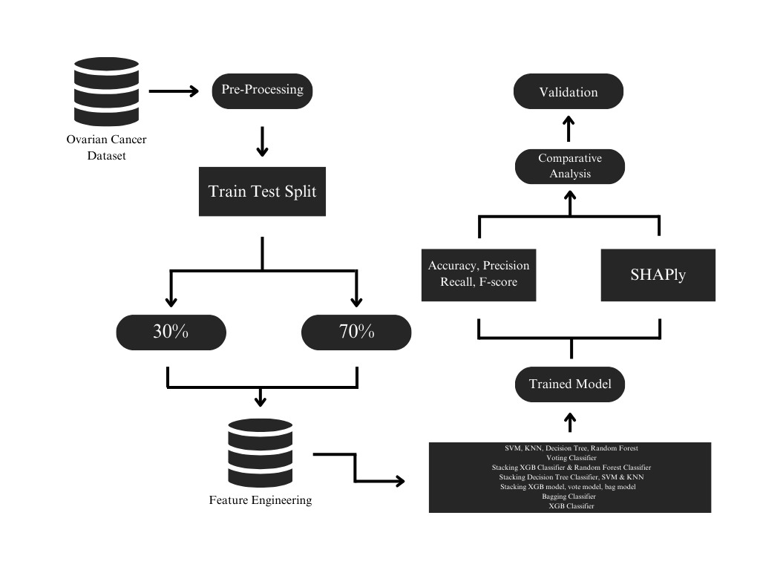

Figure 4.1 Proposed Method Workflow

1. Data Collection:

The foundation of our study lies in a diverse and comprehensive dataset comprising clinical and genetic information of ovarian cancer patients. Collaboration with healthcare institutions and research centers will facilitate access to a large and representative dataset, ensuring the inclusion of various demographics, tumor subtypes, and relevant biomarkers. The dataset will be meticulously curated to maintain data integrity and relevance to our research objectives.

2. Preprocessing:

In the initial phase of our methodology, comprehensive preprocessing steps will be applied to ensure the dataset's suitability for machine learning. This involves handling missing values, normalizing numerical features, and encoding categorical variables. The goal is to create a clean and standardized dataset, minimizing potential biases and optimizing the performance of machine learning algorithms in ovarian cancer detection.

3. Train-Test Split (30% Training, 70% Testing):

To assess the generalization performance of our models, a train-test split will be employed, allocating 30% of the dataset for training and 70% for testing. This ensures the models are trained on a representative subset of the data and evaluated on a separate, unseen portion, allowing us to estimate their real-world performance.

4. Feature Engineering:

Feature engineering is a crucial step in enhancing the discriminatory power of the models. Techniques such as Recursive Feature Elimination (RFE) will be utilized to identify the most informative features contributing to ovarian cancer detection. This process aims to reduce dimensionality and improve model interpretability.

5. Algorithms Used

A) Support Vector Machine (SVM):

Support Vector Machines (SVM) is a powerful supervised learning algorithm used for classification and regression tasks. In the context of ovarian cancer detection, SVM aims to find the optimal hyperplane that separates cancer and non-cancer cases in feature space. Its ability to handle high-dimensional data and nonlinear relationships makes it suitable for this complex medical application. SVM maximizes the margin between different classes, enhancing generalization to unseen data. However, parameter tuning is crucial, and the algorithm's performance may be influenced by the choice of the kernel function.

B) K-Nearest Neighbors (KNN):

K-Nearest Neighbors (KNN) is a non-parametric and instance-based learning algorithm used for both classification and regression tasks. In the context of ovarian cancer detection, KNN assigns a new data point to the class based on the majority class of its k-nearest neighbors. KNN is sensitive to the choice of distance metric and the number of neighbors (k). While it is robust to noisy data, its performance may be influenced by the curse of dimensionality, requiring careful preprocessing and feature selection.

C) Decision Tree:

Decision Trees are versatile and interpretable machine learning models that recursively split the dataset based on features to make decisions. In ovarian cancer detection, Decision Trees can reveal important features contributing to classification. However, they are prone to overfitting, and their performance may vary with different hyperparameters. Ensemble methods like Random Forest address overfitting by combining multiple decision trees, enhancing predictive accuracy.

D) Random Forest:

Random Forest is an ensemble learning method that constructs multiple Decision Trees during training and outputs the mode of the classes (classification) or the mean prediction (regression) of the individual trees. In the context of ovarian cancer detection, Random Forest mitigates overfitting and increases accuracy by aggregating predictions from diverse trees. It is robust, handles high-dimensional data, and provides feature importance scores.

E) Voting Classifier:

A Voting Classifier combines the predictions of multiple individual models to improve overall predictive accuracy. In the context of ovarian cancer detection, combining diverse algorithms like SVM, KNN, and Decision Tree in a Voting Classifier can lead to more robust and accurate predictions. It leverages the strengths of individual models, providing a balanced and informed decision-making process.

F) Stacking Classifiers:

Stacking involves training multiple base models and combining their predictions using a meta-model. In the context of ovarian cancer detection, stacking models like XGB Classifier and Random Forest Classifier, or Decision Tree Classifier, SVM, and KNN, can leverage the complementary strengths of diverse algorithms, potentially improving overall performance.

G) Bagging Classifier:

Bagging, or Bootstrap Aggregating, involves training multiple instances of the same base model on different subsets of the training data. In ovarian cancer detection, a Bagging Classifier can enhance robustness and reduce overfitting, particularly when applied to models like Decision Trees.

H) XGB Classifier:

XGBoost (Extreme Gradient Boosting) is a scalable and efficient implementation of gradient boosting. In ovarian cancer detection, the XGB Classifier excels in handling imbalanced datasets, capturing complex relationships, and providing interpretable feature importance scores. However, parameter tuning is crucial for optimal performance.

These diverse set of machine learning algorithms presented here offers a comprehensive toolkit for ovarian cancer detection. The choice of algorithm depends on factors such as dataset characteristics, interpretability requirements, and the desired balance between bias and variance. Through careful consideration and experimentation, these algorithms contribute to advancing the accuracy and interpretability of ovarian cancer detection models.

6. Training the Model:

Several machine learning algorithms, including Logistic Regression, Random Forest, Support Vector Machines (SVM), and Neural Networks, will be trained on the preprocessed dataset. Each algorithm will undergo thorough training to learn the patterns and relationships within the data, optimizing their ability to differentiate between ovarian cancer cases and healthy instances.

7. Evaluation Metrics:

Model performance will be evaluated using standard metrics, including accuracy, precision, recall, and F1-score. These metrics provide a comprehensive assessment of the models' ability to correctly classify positive and negative instances, offering insights into their overall effectiveness in ovarian cancer detection.

Accuracy:

Accuracy serves as a fundamental metric in machine learning, gauging the frequency with which a model accurately forecasts outcomes. It encapsulates the model's precision by quantifying the ratio of correct predictions to the total predictions made. This metric is pivotal in assessing the overall effectiveness and reliability of a machine learning model. A higher accuracy implies a superior ability to correctly identify and classify instances, signifying robust predictive performance. However, it is essential to consider the specific characteristics of the dataset; in instances of imbalanced classes, accuracy alone may not provide a comprehensive evaluation. While accuracy remains a primary indicator of model efficacy, a holistic assessment incorporating additional metrics such as precision, recall, and F1 score provides a more nuanced understanding of the model's predictive capabilities across various scenarios and class distributions.

Accuracy = True Negatives(TN) + True Positive(TP) / True Negatives(TN) + True Positive(TP) + False Negative(FN)

Precision:

Precision serves as a crucial metric in evaluating the effectiveness of a machine learning model, specifically reflecting the accuracy of positive predictions. This metric quantifies the model's precision in correctly identifying instances of the positive class among its predictions. In essence, precision measures the quality of positive predictions, shedding light on the model's capability to avoid false positives. A higher precision score indicates a lower rate of misclassification among positive predictions, emphasizing the reliability of the model in correctly identifying relevant instances. Precision is especially pertinent in scenarios where minimizing false positives is imperative, such as in medical diagnostics or fraud detection, as it ensures that the positive predictions made by the model are more likely to be accurate and trustworthy. Consequently, precision stands as a fundamental measure in assessing the model's ability to make high-quality positive predictions.

Precision = True Positive(TP) / True Positive(TP) + False Positives(FP)

Recall:

Recall, often referred to as the true positive rate (TPR), signifies the proportion of instances within a specific class that a machine learning model accurately recognizes as part of the designated "positive class." It is a critical metric for evaluating a model's ability to capture all relevant instances of the target class, thereby minimizing false negatives. In simpler terms, recall quantifies the model's effectiveness in identifying and recalling instances of interest from the entire set of occurrences in the positive class. A high recall indicates that the model is adept at capturing a significant portion of the positive class instances, emphasizing its sensitivity to identifying true positives while minimizing the risk of overlooking actual positive occurrences. Therefore, a robust machine learning model with high recall ensures a comprehensive and reliable identification of instances within the specified positive class.

Recall = True Positive(TP) / True Positive(TP) + False Negative(FN)

F1 Score:

The F1 score, a pivotal metric in classification evaluations, serves as the harmonic mean of precision and recall. Specifically designed for binary and multi-class classification tasks, this score amalgamates precision and recall into a singular metric, providing a comprehensive assessment of model performance. By encapsulating both precision, which gauges the accuracy of positive predictions, and recall, which measures the model's ability to identify all positive instances, the F1 score offers a balanced insight into the classifier's effectiveness. Its harmonic mean nature ensures that a significant deviation in either precision or recall is duly reflected, making it particularly useful in scenarios where achieving equilibrium between false positives and false negatives is critical. In essence, the F1 score encapsulates the synergy between precision and recall, offering a nuanced and holistic evaluation of a classifier's classification prowess.

F1 Score = True Positive(TP) / True Positive(TP) + ½ [False Positives(FP) + False Negatives(FN)]

8. SHAPly Values:

To enhance interpretability, SHAP (SHapley Additive exPlanations) values will be calculated. This will help us understand the contribution of each feature to the model's predictions, providing valuable insights into the decision-making process.

9. Comparative Analysis of Algorithms:

A comparative analysis will be conducted to evaluate the performance of different machine learning algorithms based on their accuracy. This analysis will help identify the most effective algorithm for ovarian cancer detection and understand the trade-offs between precision, recall, and computational efficiency.

10. Validation:

The final step involves model validation to ensure robustness and generalizability. This may include cross-validation techniques to further assess the models' performance across different subsets of the data, validating their efficacy in diverse scenarios.

In conclusion, this proposed methodology aims to leverage machine learning for effective ovarian cancer detection by combining rigorous preprocessing, appropriate train-test split, feature engineering, model training, comprehensive evaluation, interpretability analysis using SHAPly values, and a comparative analysis of algorithms. The validation process ensures the reliability and generalizability of the proposed models.

**CHAPTER-5**

**OBJECTIVES**



Figure 5.1 Objectives

1. Develop and Implement a Robust Machine Learning Model:

The development and implementation of a robust machine learning model are critical components in the quest for accurate ovarian cancer detection. The success of such a model hinges on meticulous planning, data preprocessing, and algorithm selection. The first step involves acquiring a comprehensive dataset that encompasses a diverse range of features, including clinical and genetic attributes. This dataset forms the foundation upon which the model is constructed.

Data preprocessing is a crucial stage to ensure the quality and reliability of the dataset. Addressing missing values, normalizing features, and encoding categorical variables contribute to the optimization of the data for machine learning algorithms. Following preprocessing, the selection of an appropriate algorithm becomes pivotal. In the context of ovarian cancer detection, algorithms like Logistic Regression, Random Forest, Support Vector Machines, and Neural Networks may be considered.

Implementation involves training the selected model on the prepared dataset and fine-tuning its parameters for optimal performance. Rigorous testing and validation procedures are then employed to assess the model's accuracy, precision, recall, and F1 score. The iterative nature of model development and refinement ensures that the final implementation is robust, capable of generalizing well to new data, and contributing to the accurate detection of ovarian cancer.

In conclusion, the development and implementation of a robust machine learning model for ovarian cancer detection involve meticulous data handling, algorithm selection, and iterative refinement. The success of this segment is pivotal to the overall success of the research paper.

2. Feature Selection and Extraction Optimization:

Feature selection and extraction optimization are key aspects in enhancing the efficiency and interpretability of machine learning models for ovarian cancer detection. Ovarian cancer datasets often comprise numerous features, some of which may be redundant or irrelevant. Feature selection techniques aim to identify and retain the most informative features, contributing to model accuracy and reducing computational complexity.

One common method for feature selection is Recursive Feature Elimination (RFE), which systematically removes less important features, iteratively refining the model. Additionally, feature extraction techniques like Principal Component Analysis (PCA) can be applied to transform the original feature space into a lower-dimensional representation, preserving essential information while reducing dimensionality.

The optimization of feature selection and extraction techniques plays a crucial role in enhancing the model's interpretability. Interpretability is paramount in medical applications, as it allows clinicians to understand the factors influencing predictions and fosters trust in the model's decision-making process.

In the context of ovarian cancer detection, identifying the most relevant clinical and genetic features can lead to a more streamlined and interpretable model. Balancing the trade-off between reducing dimensionality and preserving information is essential to ensure that the optimized feature set contributes meaningfully to the overall model performance.

In summary, feature selection and extraction optimization are integral components of the ovarian cancer detection research, contributing to the development of a more interpretable and efficient machine learning model.

3. Validation and Comparative Analysis:

Validation and comparative analysis serve as crucial stages in evaluating the performance of machine learning models for ovarian cancer detection. These stages ensure the reliability and generalizability of the model across diverse datasets and scenarios. Rigorous validation protocols are employed to assess the model's robustness, preventing overfitting to the training data and enhancing its ability to make accurate predictions on unseen instances.

Cross-validation, a widely used validation technique, involves partitioning the dataset into multiple subsets for training and testing the model iteratively. This process provides a more comprehensive understanding of the model's performance by evaluating it across different data configurations.

Comparative analysis involves benchmarking the developed model against existing or alternative approaches. This step is crucial for assessing the novelty and effectiveness of the proposed model. In the context of ovarian cancer detection, comparing the performance of machine learning algorithms, such as Logistic Regression, Random Forest, Support Vector Machines, and Neural Networks, provides insights into the strengths and weaknesses of each approach.

The selection of appropriate evaluation metrics, such as accuracy, precision, recall, and F1 score, contributes to a nuanced understanding of the model's performance. Additionally, the incorporation of receiver operating characteristic (ROC) curves and area under the curve (AUC) analysis enhances the discriminatory power assessment of the model.

In conclusion, validation and comparative analysis ensure the reliability, robustness, and effectiveness of the machine learning model developed for ovarian cancer detection. These stages provide valuable insights into the model's performance and contribute to the overall credibility of the research paper.

**CHAPTER-6**

**SYSTEM DESIGN & IMPLEMENTATION**

* **Importing dataset**

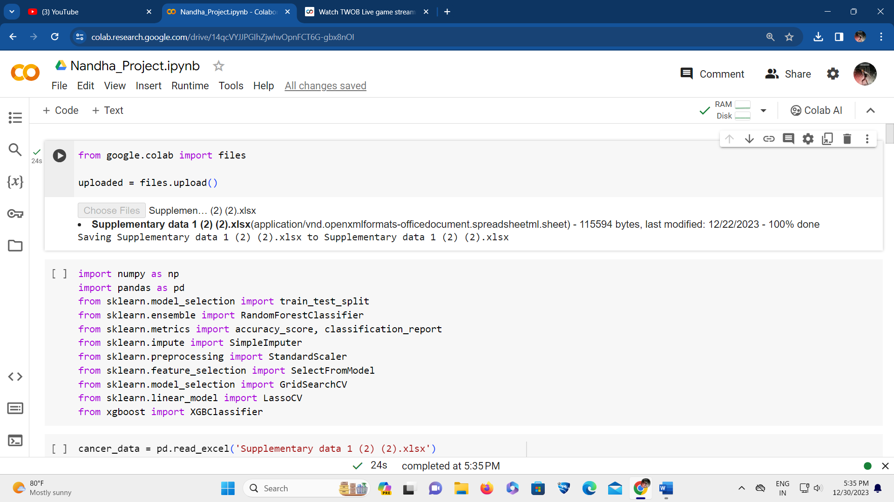

* **Importing Necessary libraries**

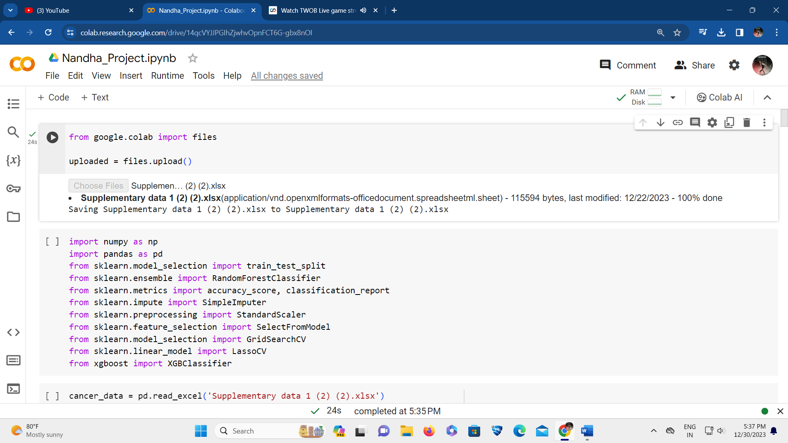

* **Excel data loaded, trailing whitespaces removed from string columns**

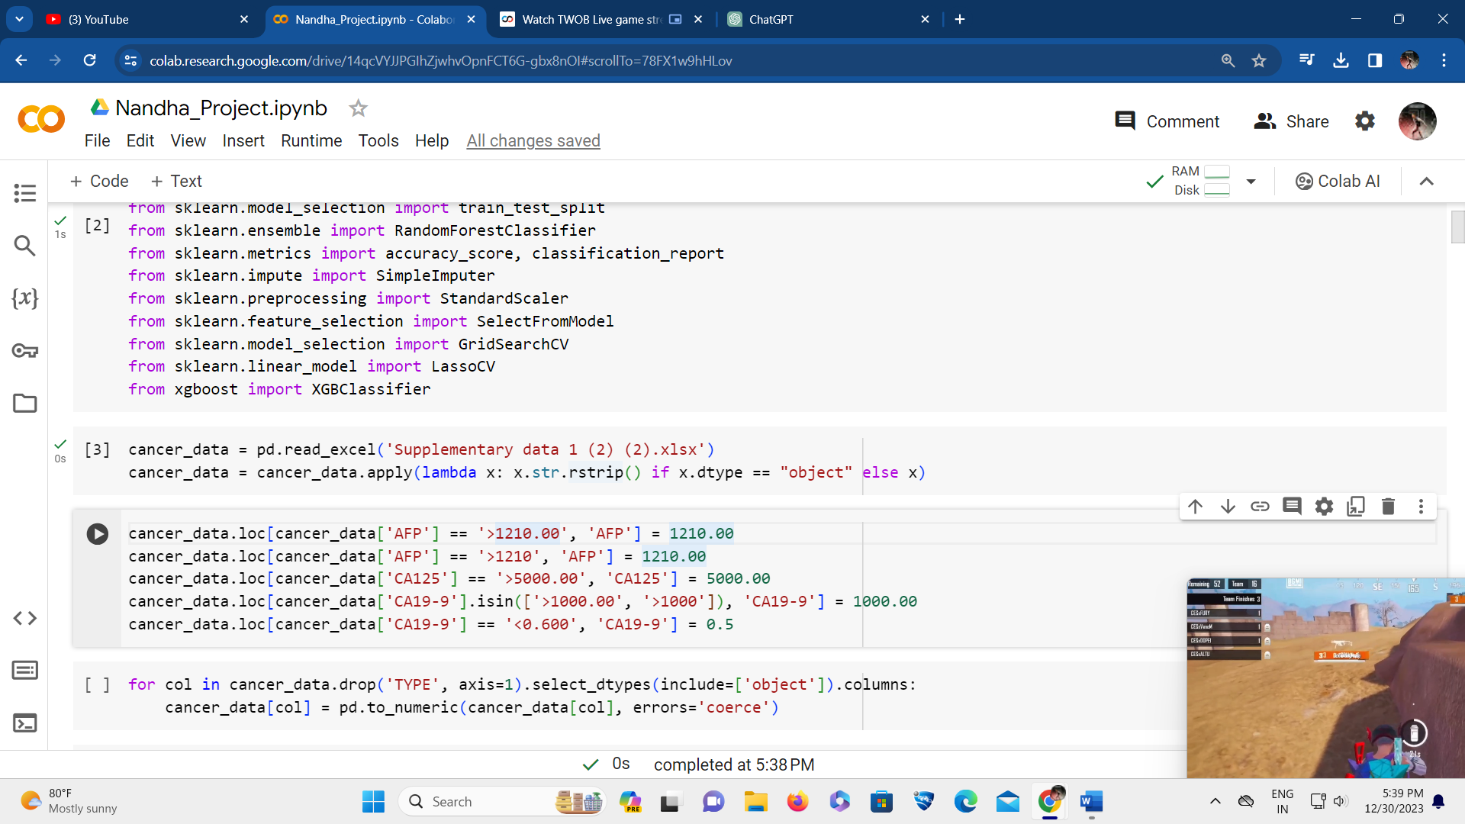.

* **Replacing specific values in columns for standardization and consistency.**

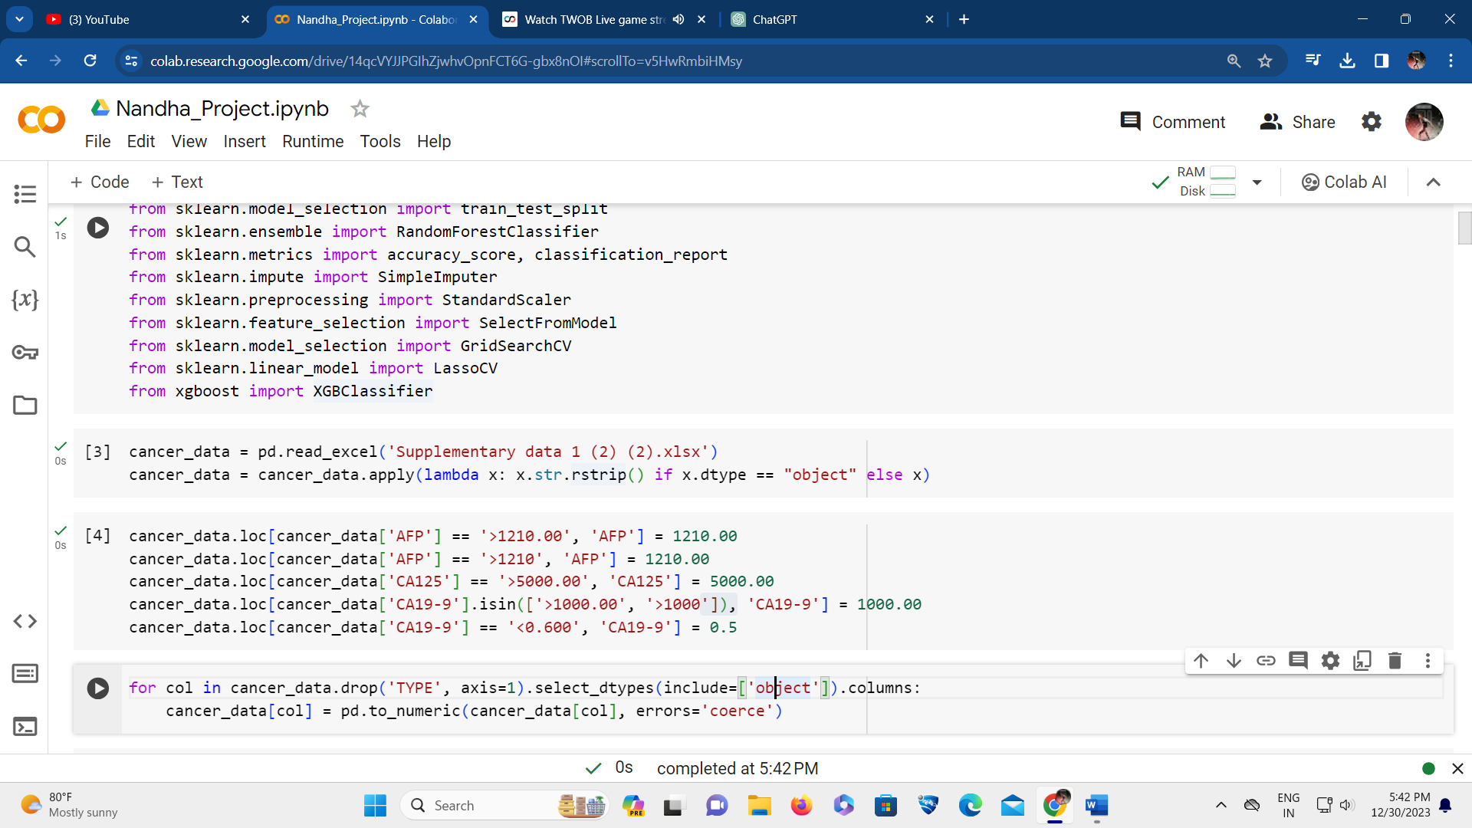

* **Converting object-type columns to numeric for data consistency**

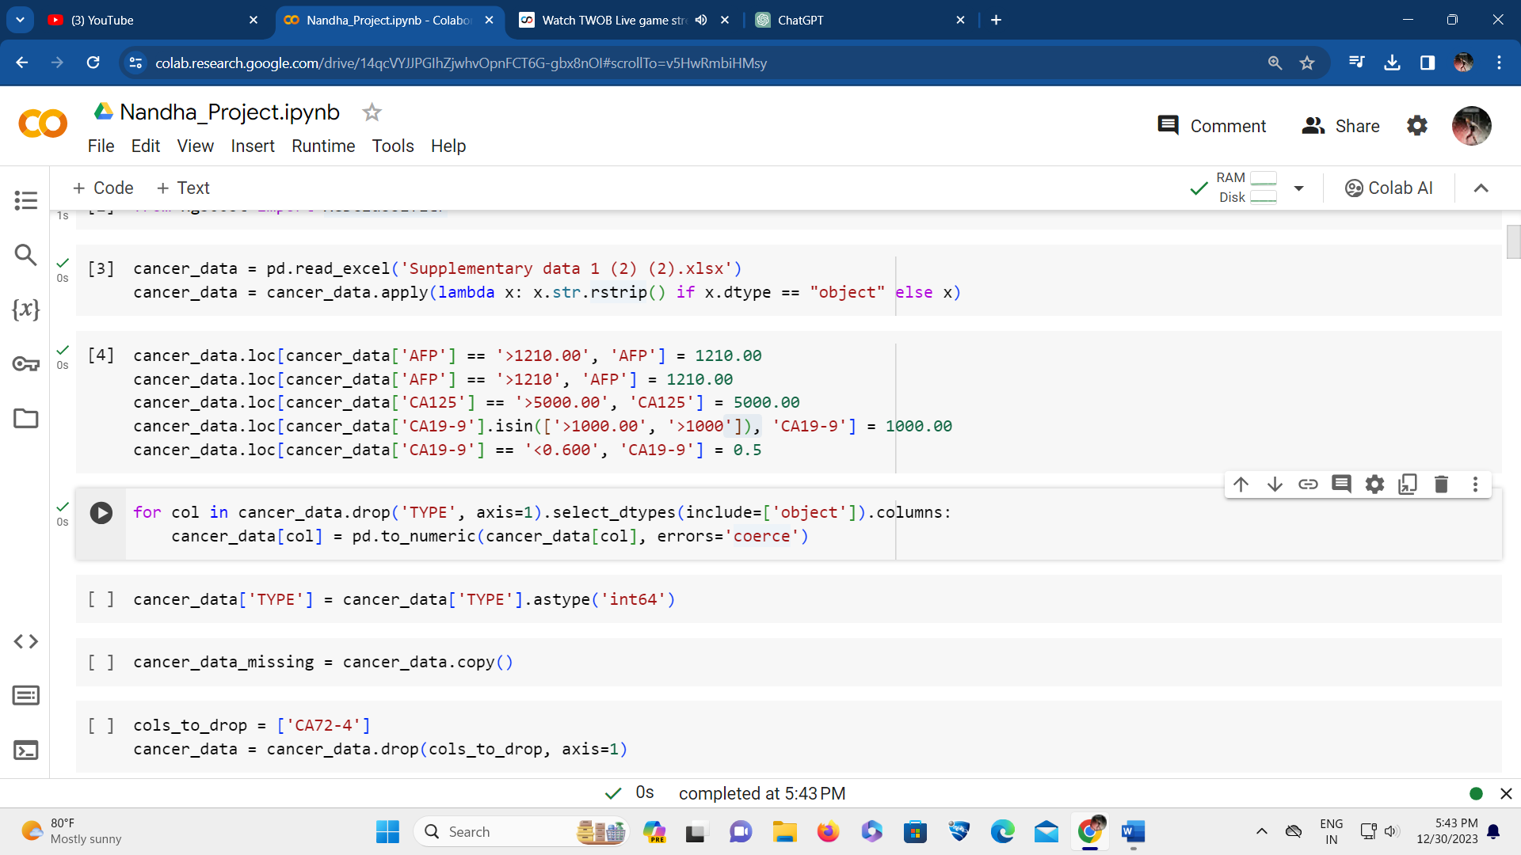

* **Converting 'TYPE' column to integer data type (int64).**

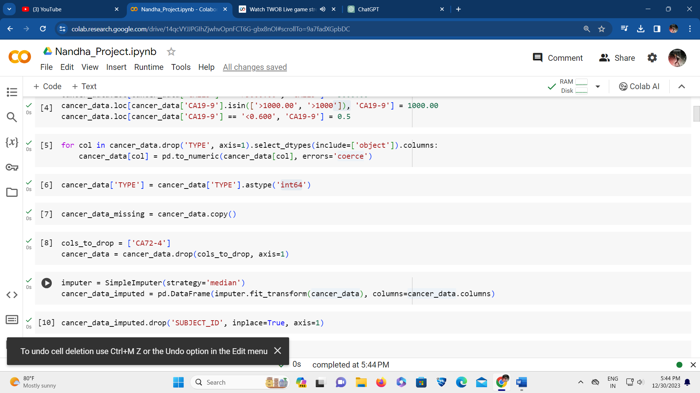

* **Creating a duplicate Data Frame for further manipulation or analysis**

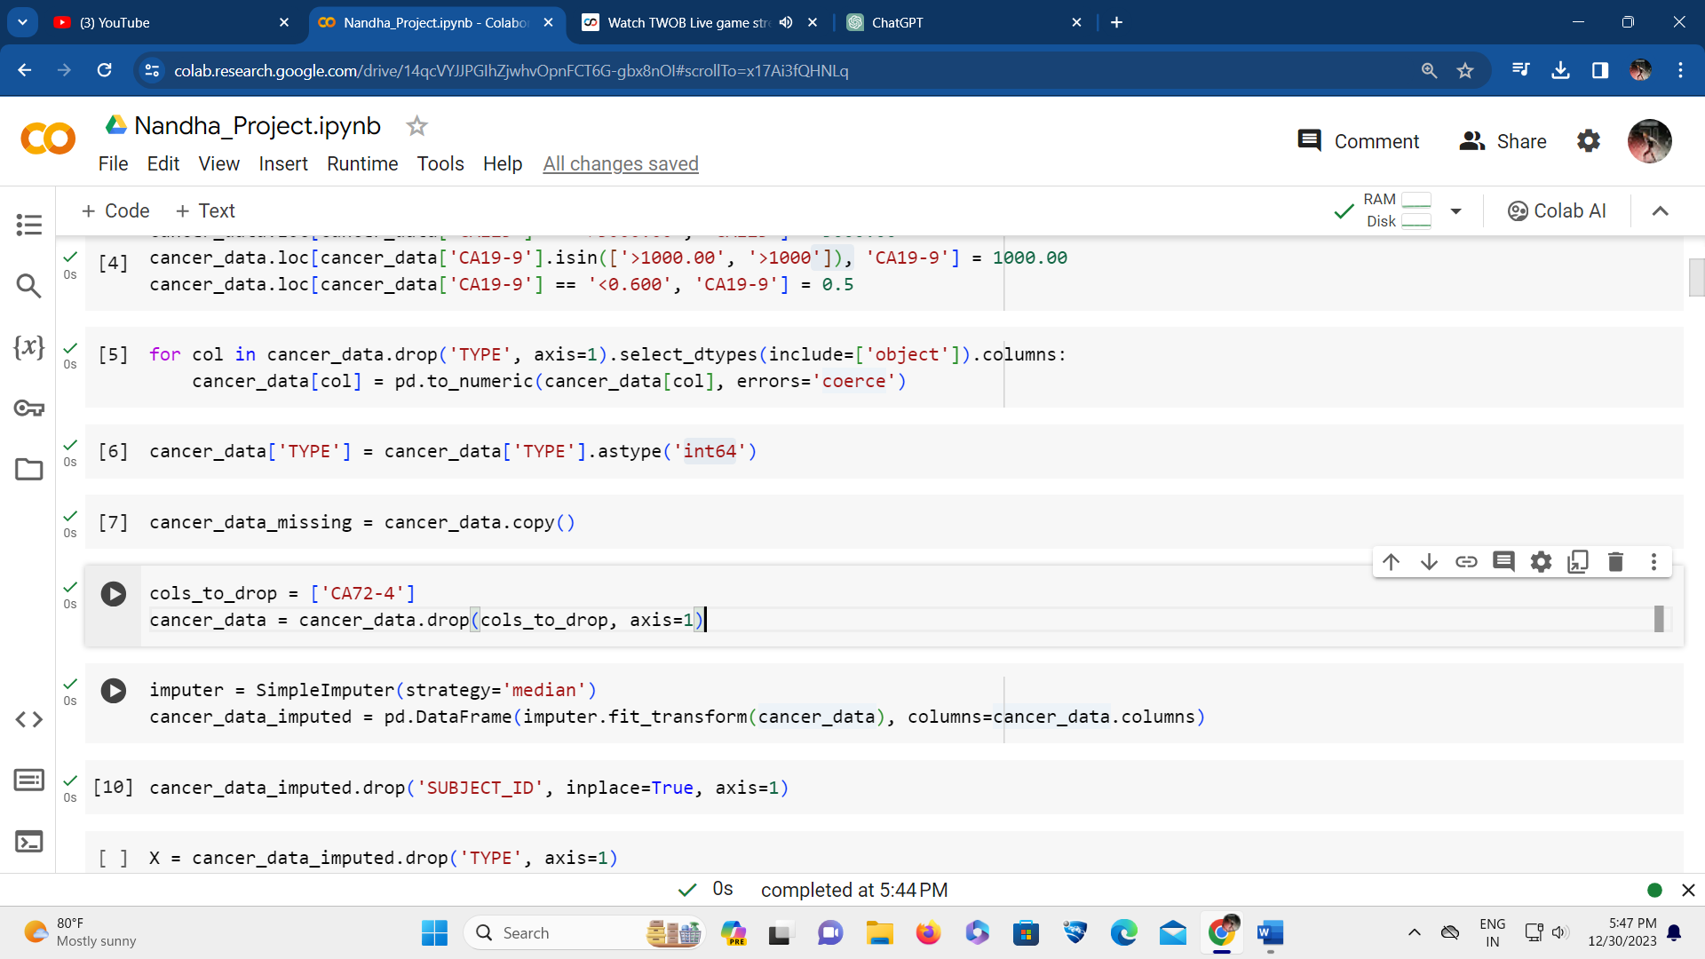

* **Dropping 'CA72-4' column from the Data Frame.**

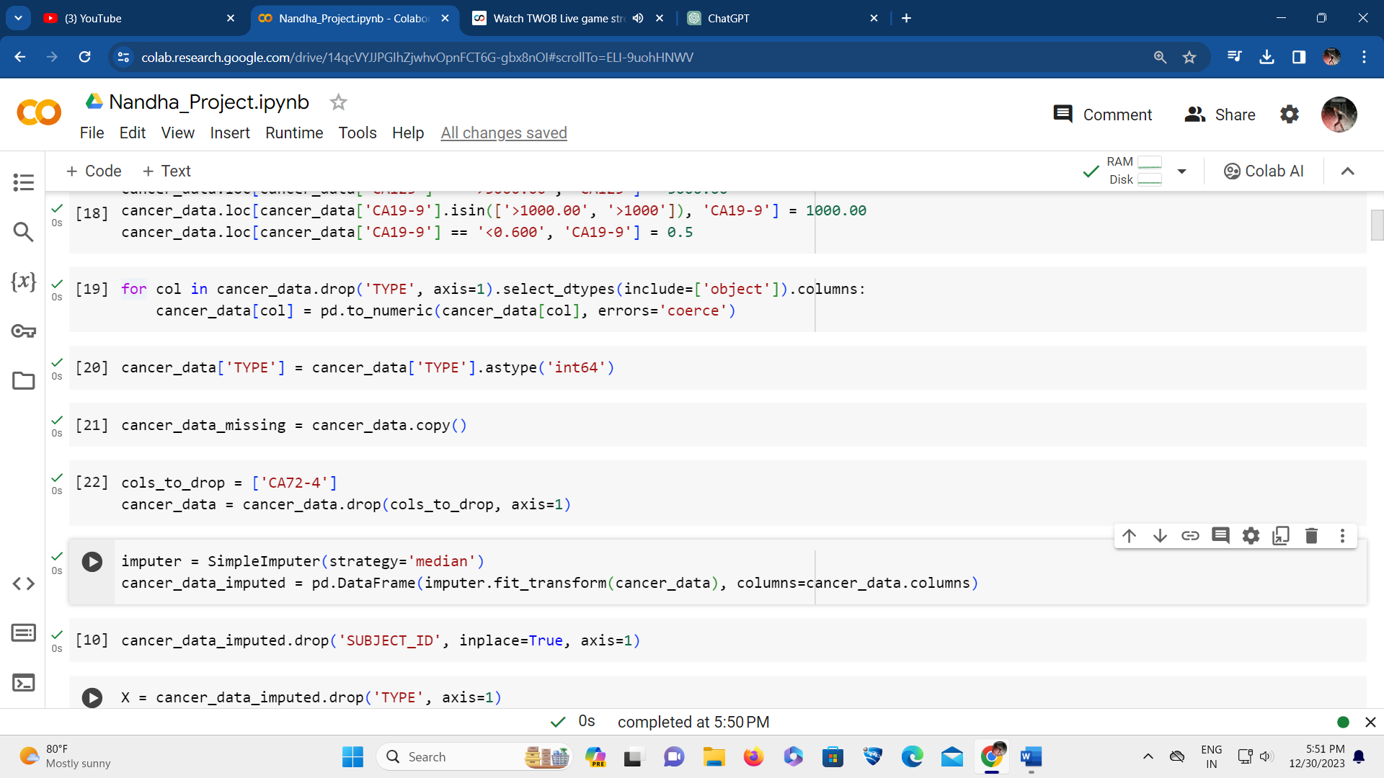

* **Imputing missing values using median strategy into a new Data Frame**

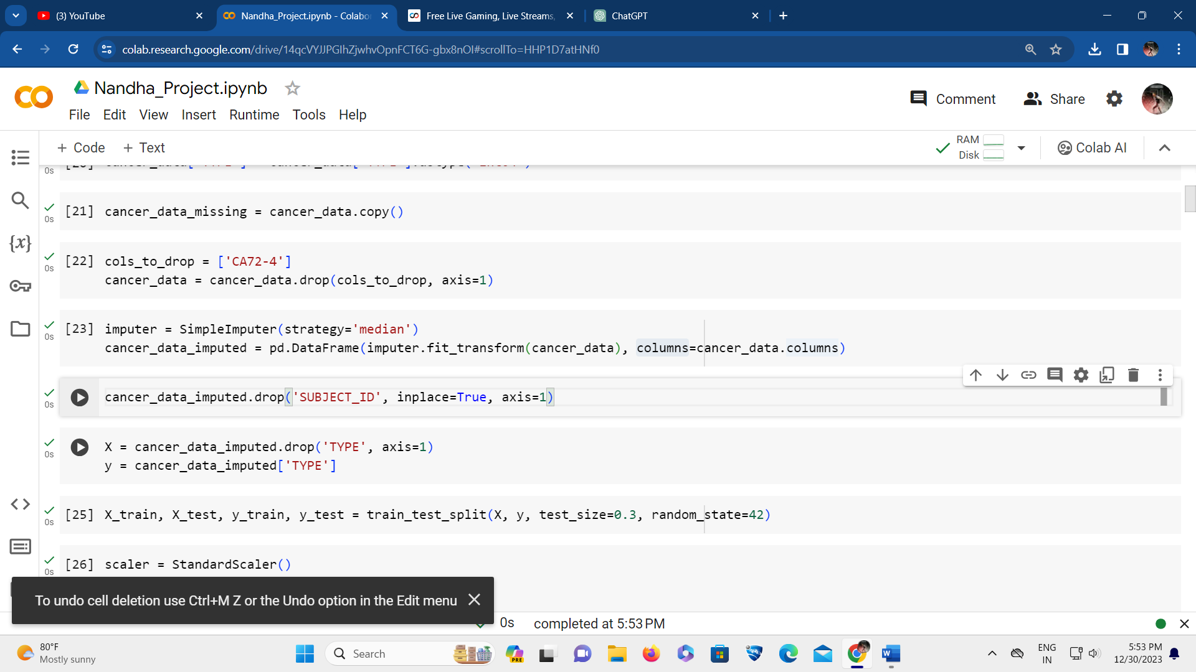

* **Dropping 'SUBJECT_ID' column from the imputed Data Frame**

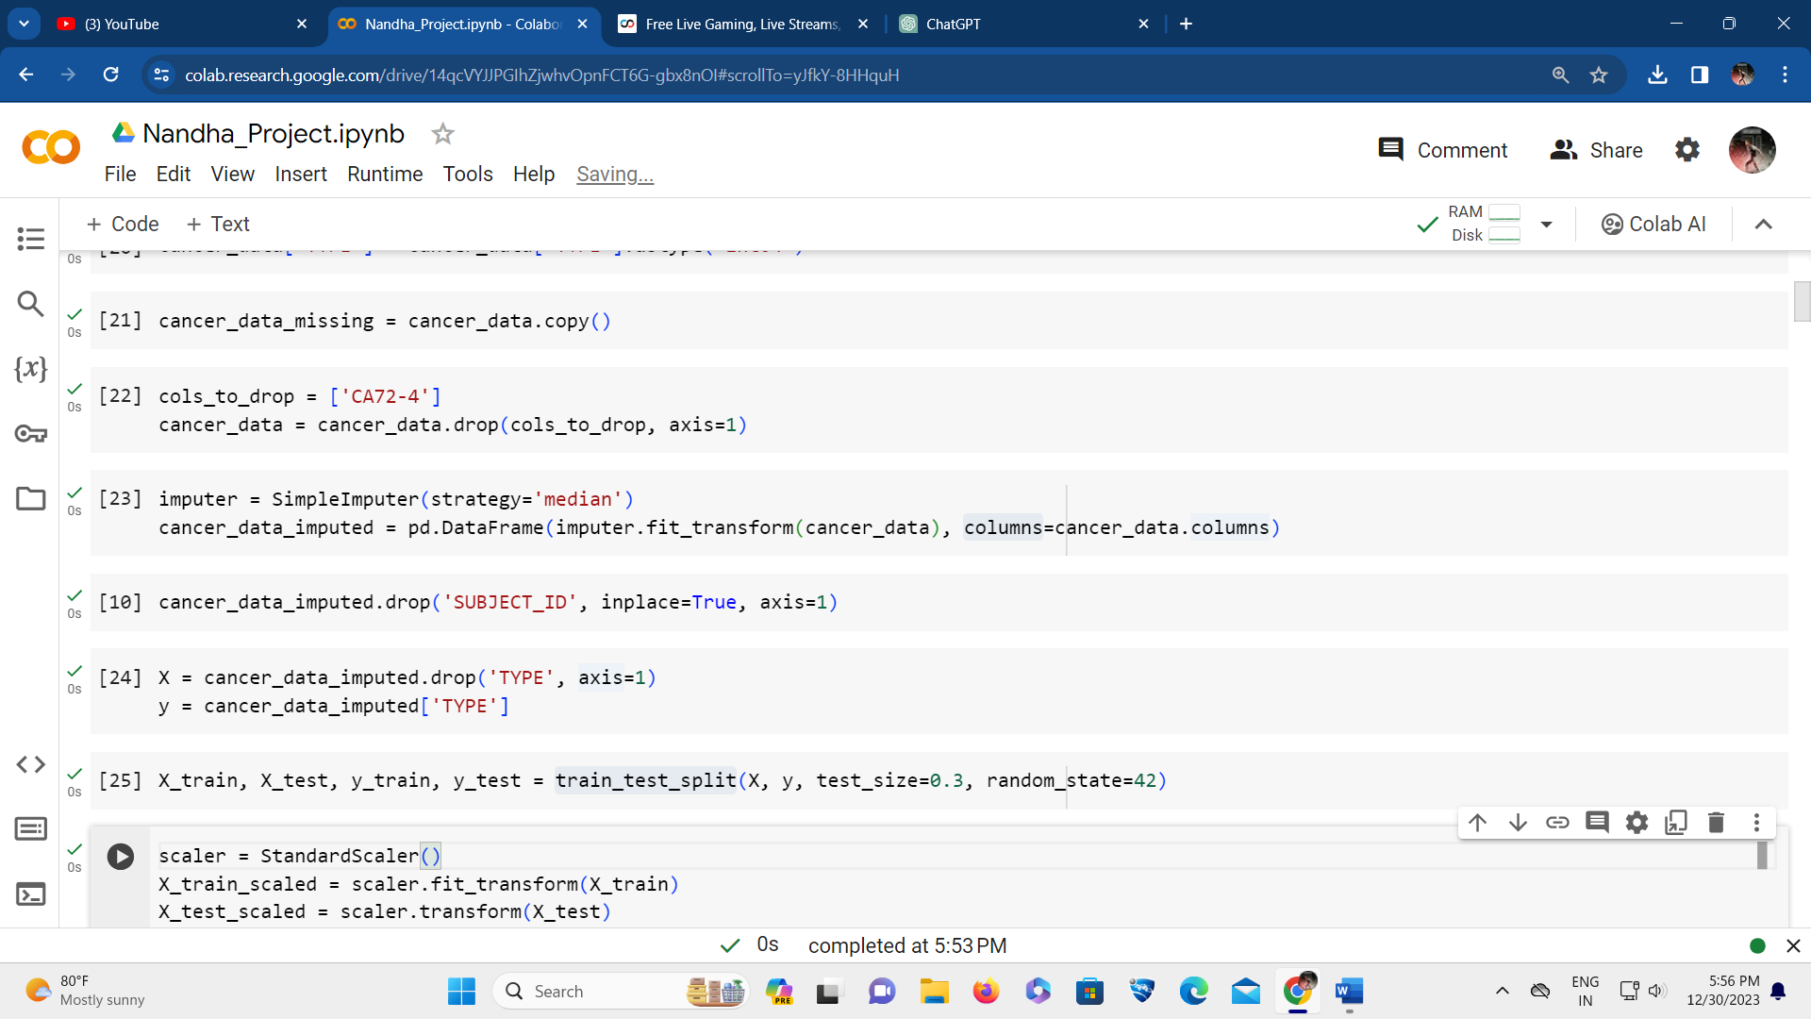

* **Defining predictors (X) and target variable (y) for analysis**



* **Splitting the data into training and testing sets (70% train, 30% test) with a random seed of 42.**

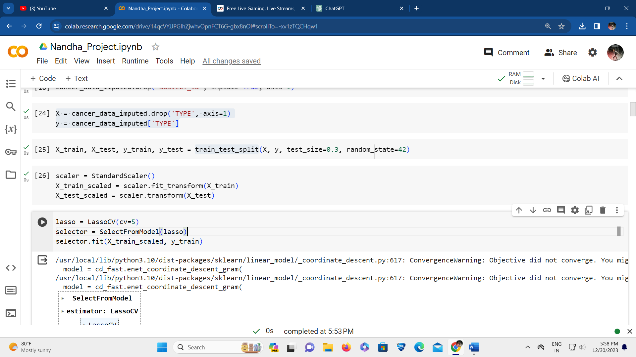

* **Scaling the training and testing predictor data using Standard Scaler**

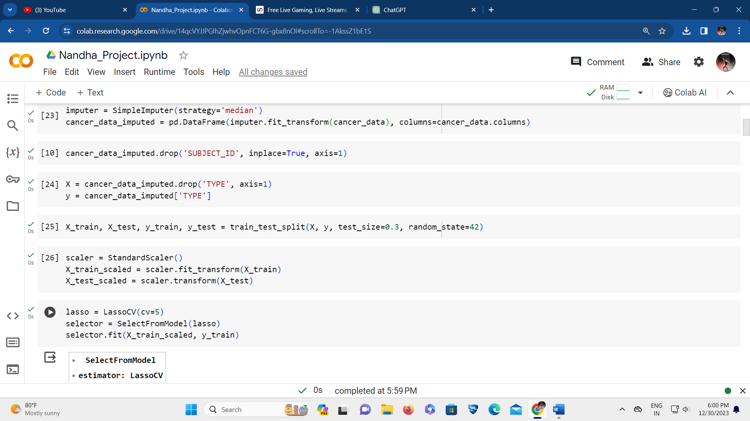

* **Using Lasso CV for feature selection with 5-fold cross-validation.**



* **Retrieving selected features using SelectFromModel.**

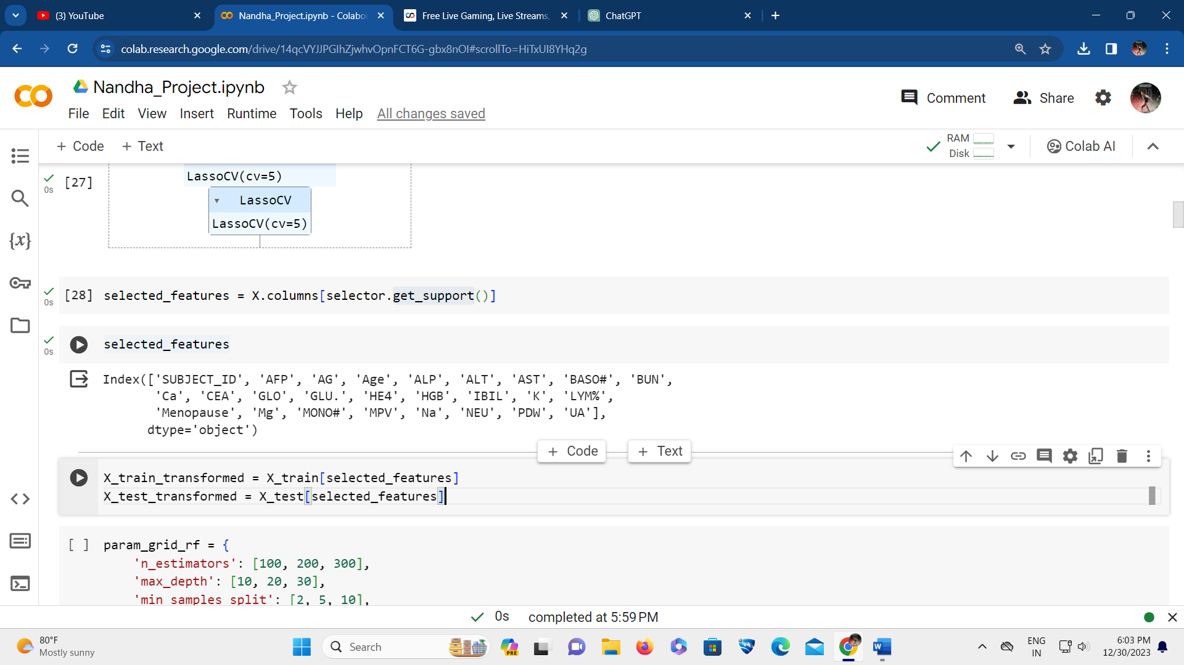

* **Selected features**

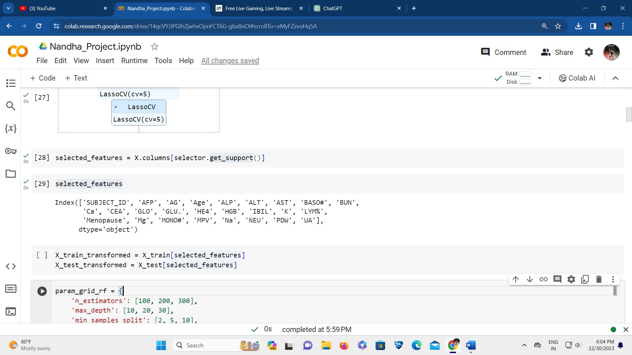

* **Transforming the training and testing datasets with selected features.**

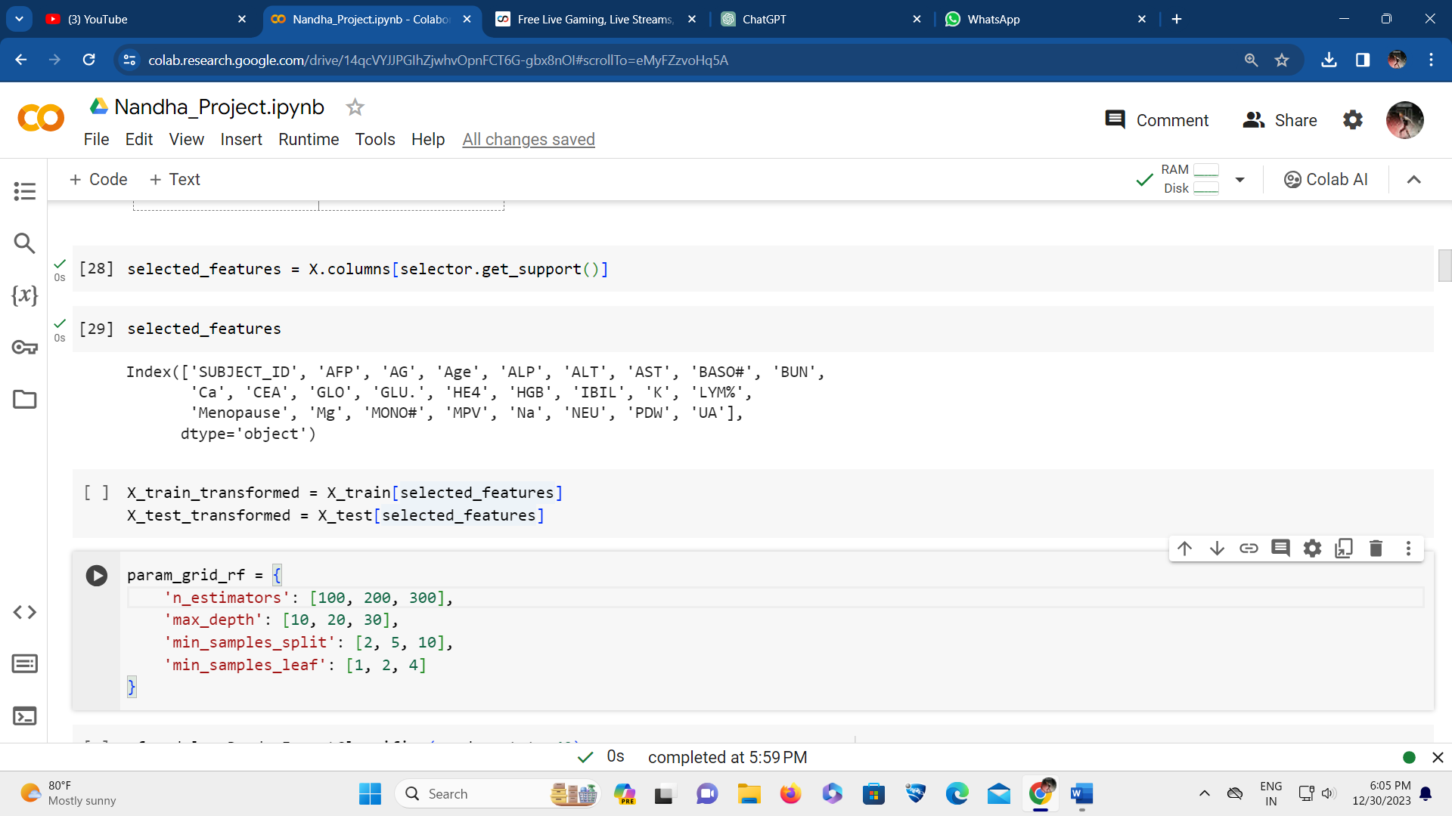

* **Random Forest hyperparameter grid for model optimization.**

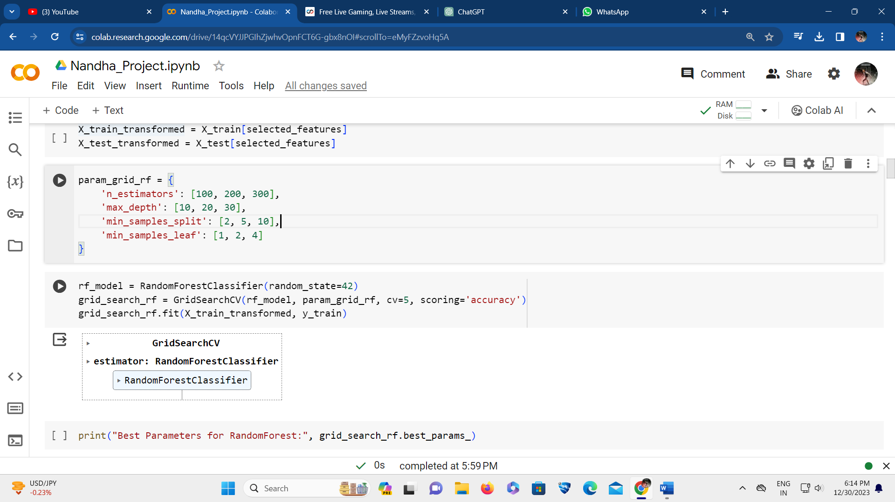

* **Performing Grid Search CV on Random Forest classifier for parameter optimization**

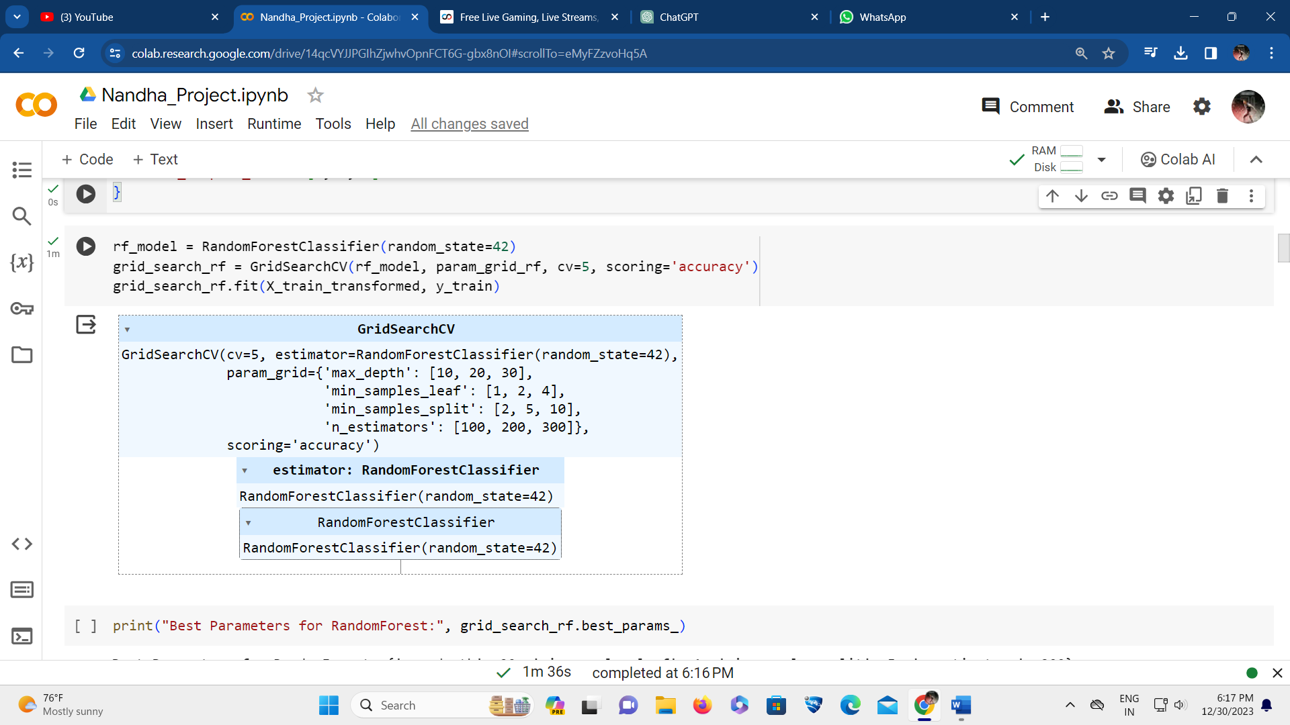

* **Obtaining the best Random Forest model from Grid Search CV results**

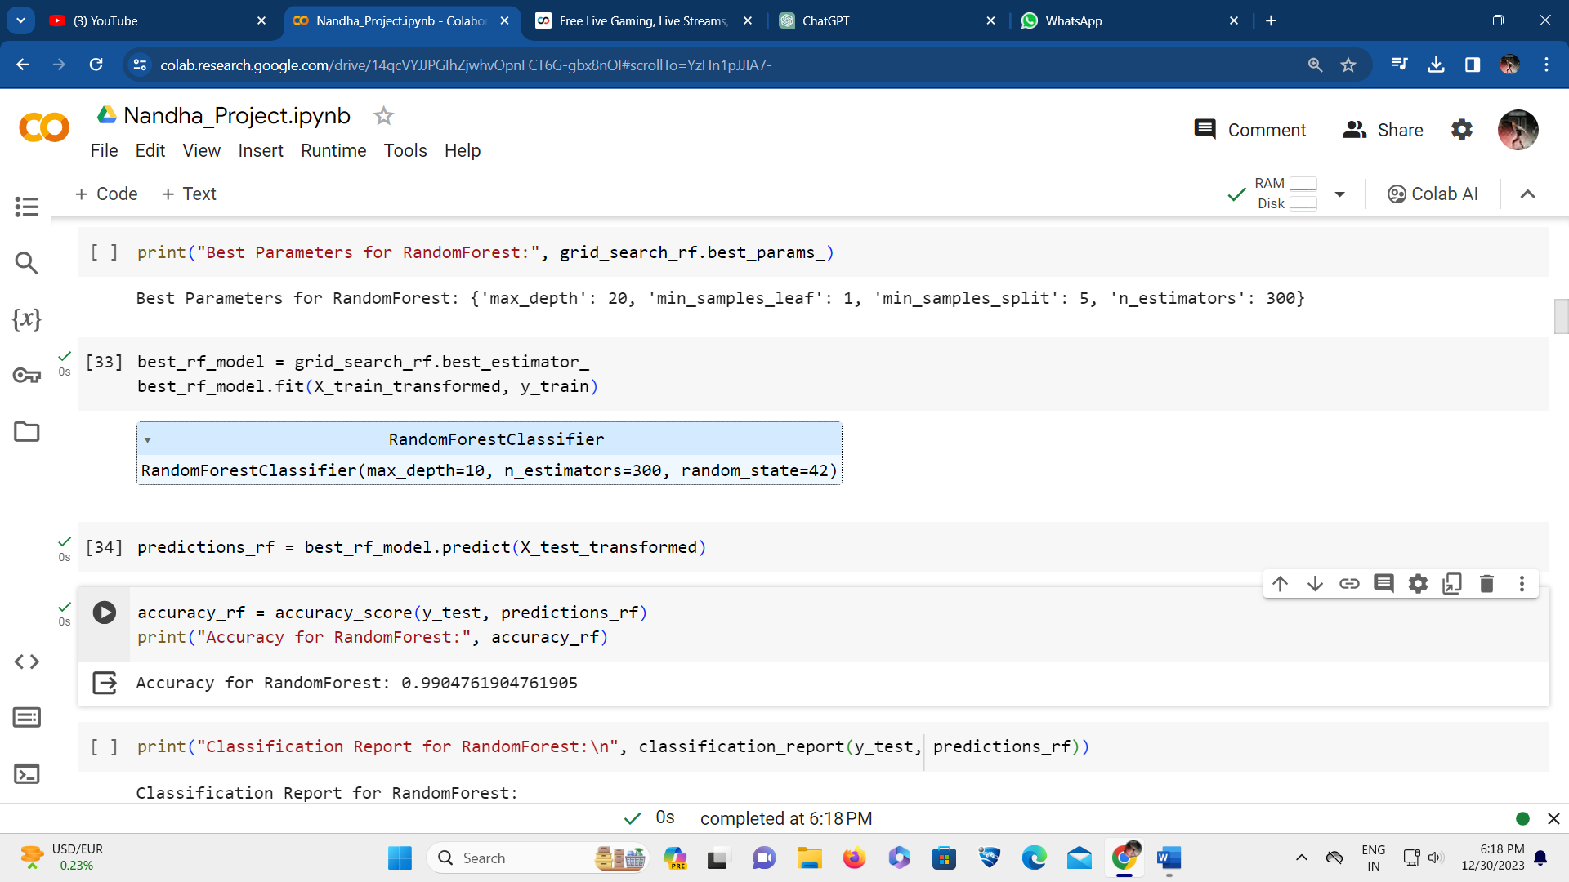

* **Generating predictions using the best Random Forest model**



* **Calculating and displaying the accuracy of the Random Forest model**



* **Displaying the classification report for the RandomForest model.**

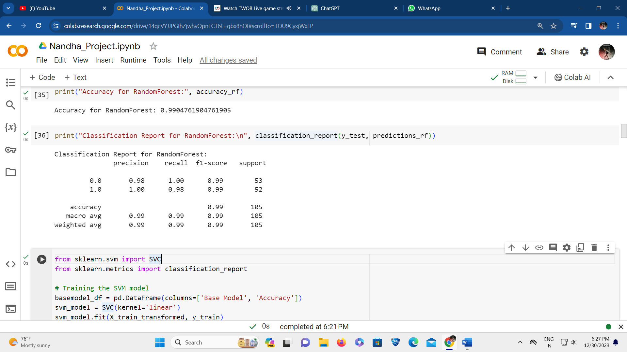

* **Evaluating SVM model, generating classification report, and recording accuracy**

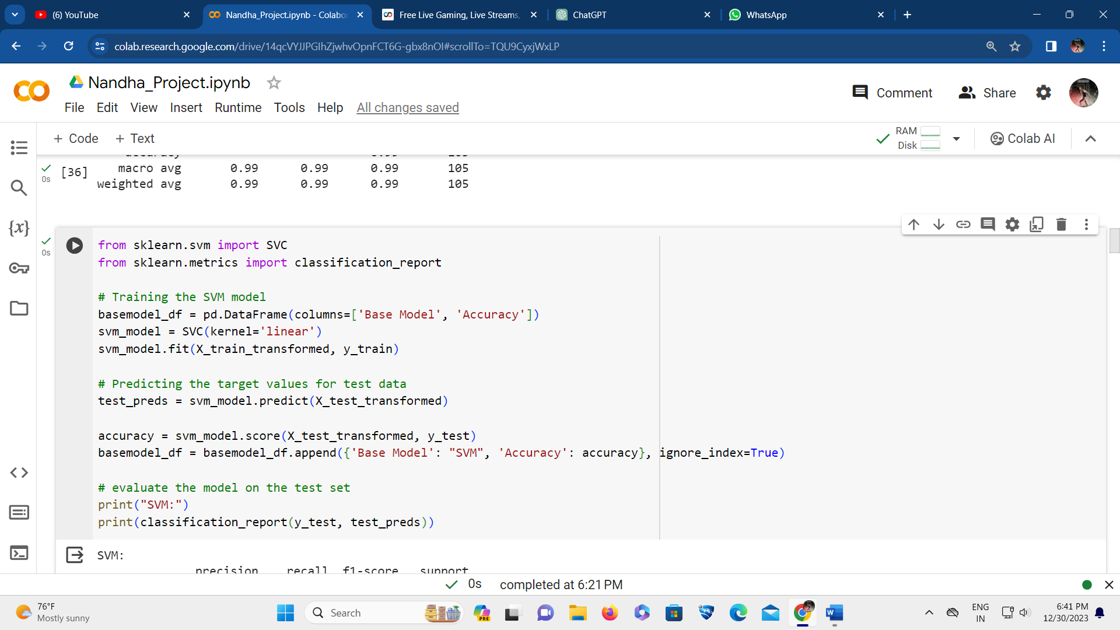

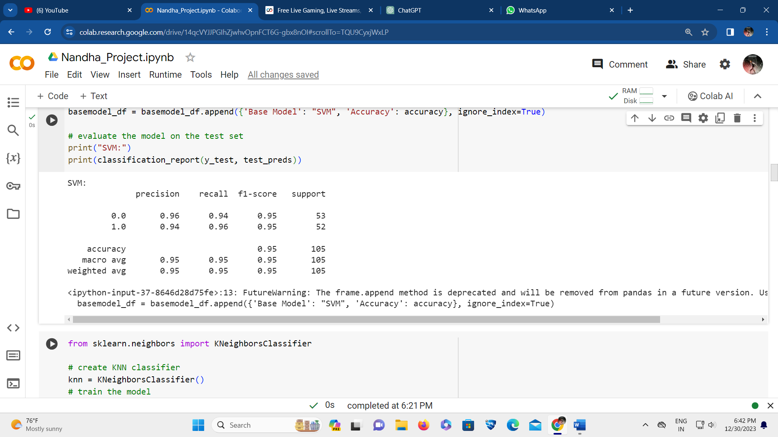

* **Training KNN classifier, assessing performance, and recording accuracy metrics.**

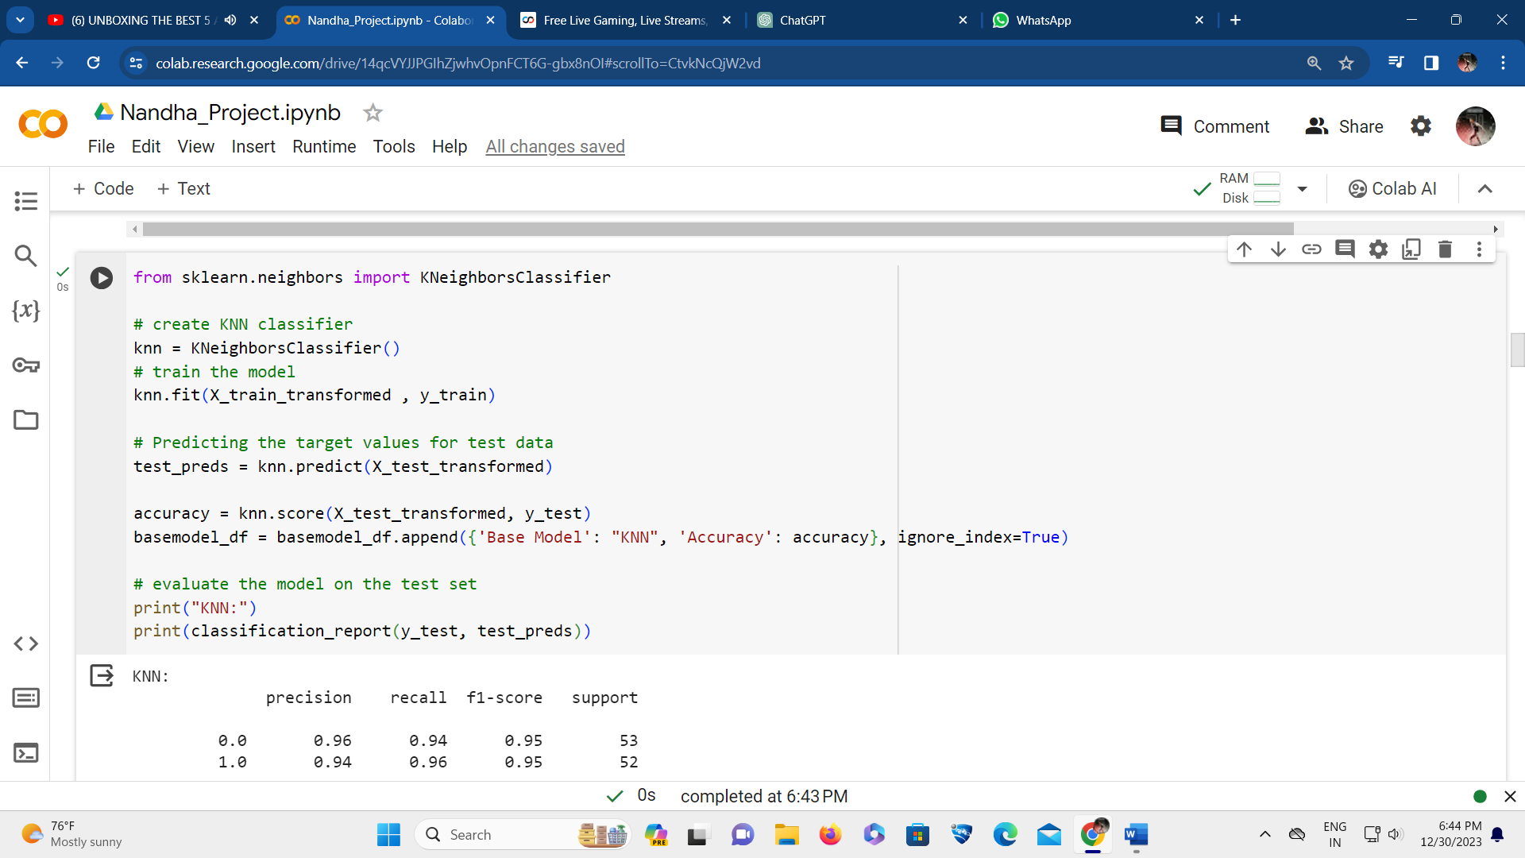

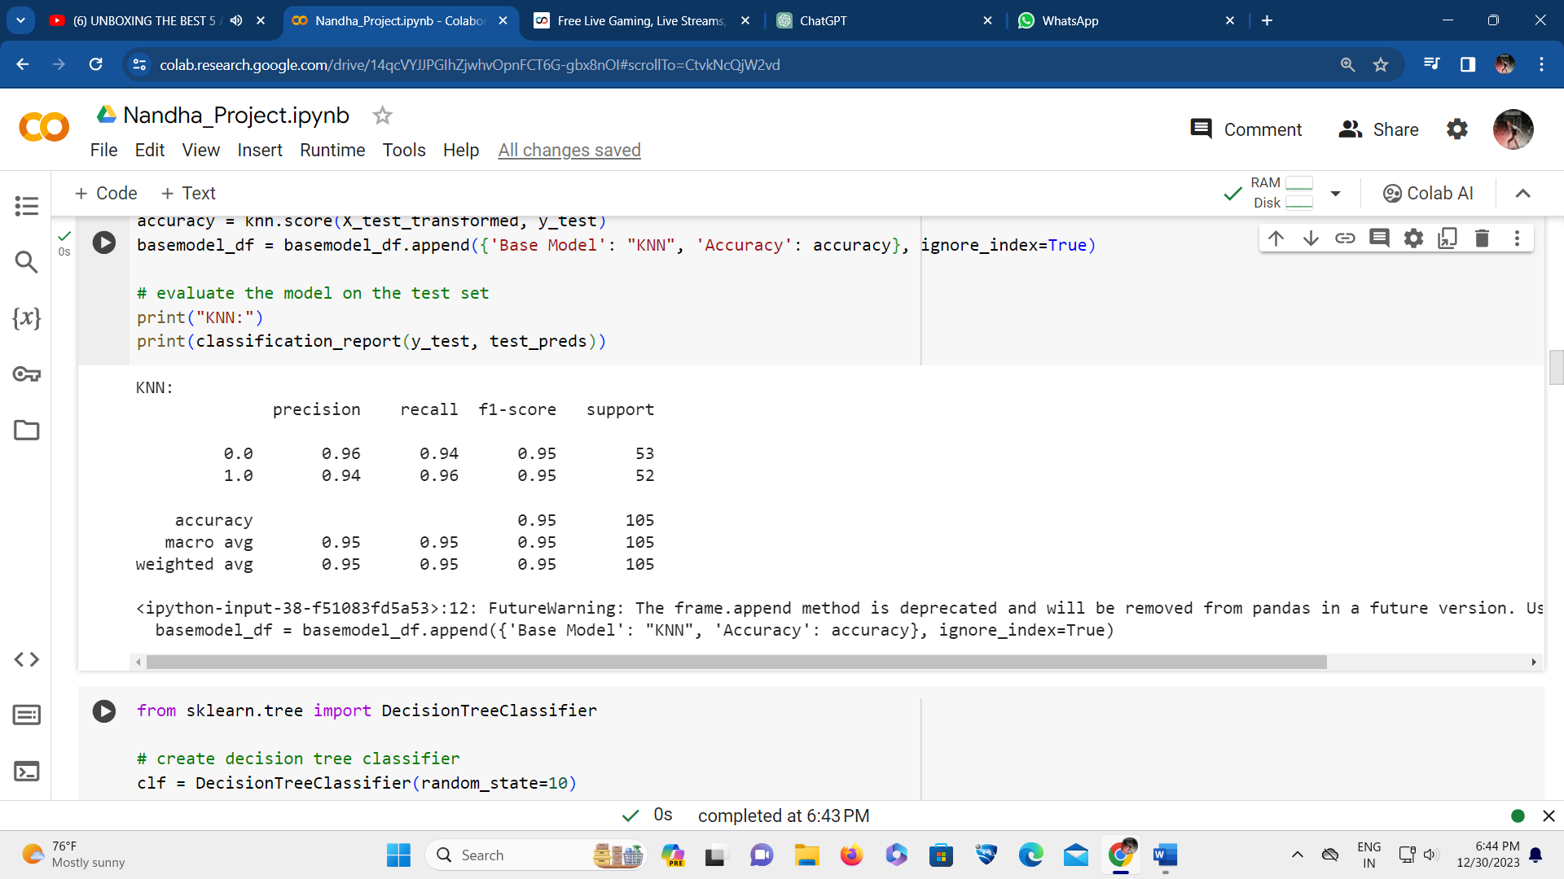

* **Implementing Decision Tree, assessing performance, and recording accuracy metrics**

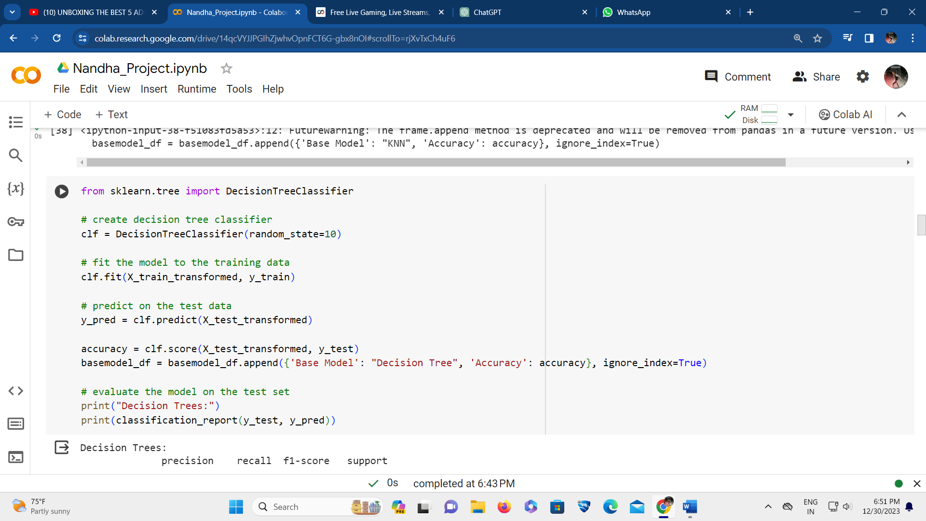

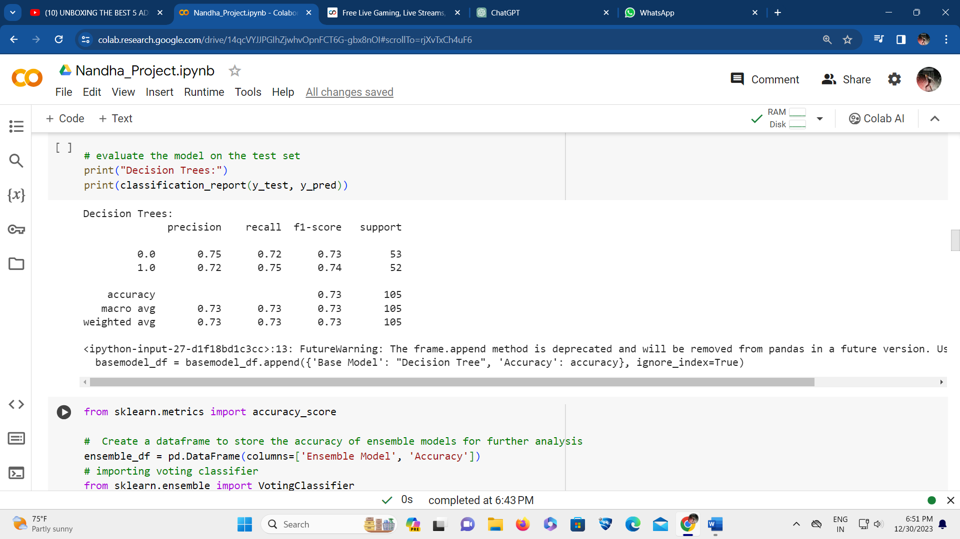

* **Creating Ensemble Model via Max Voting, Assessing Performance, Recording Accuracy.**

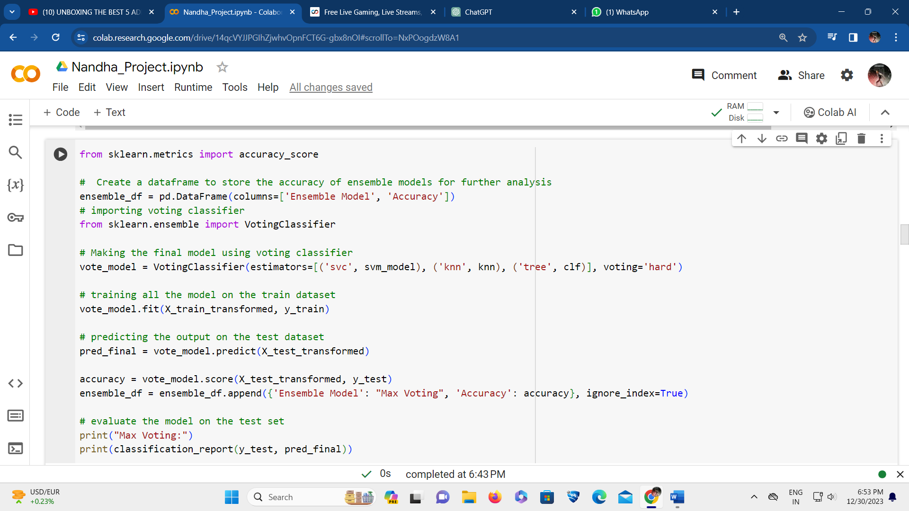

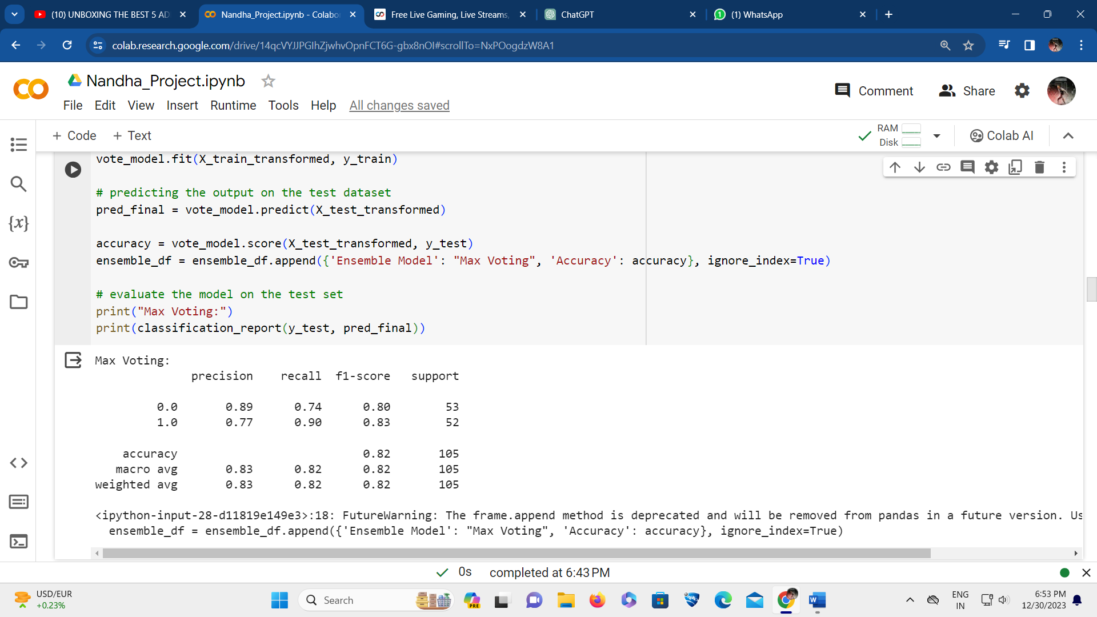

* **Installing the 'vecstack' package for machine learning model stacking**

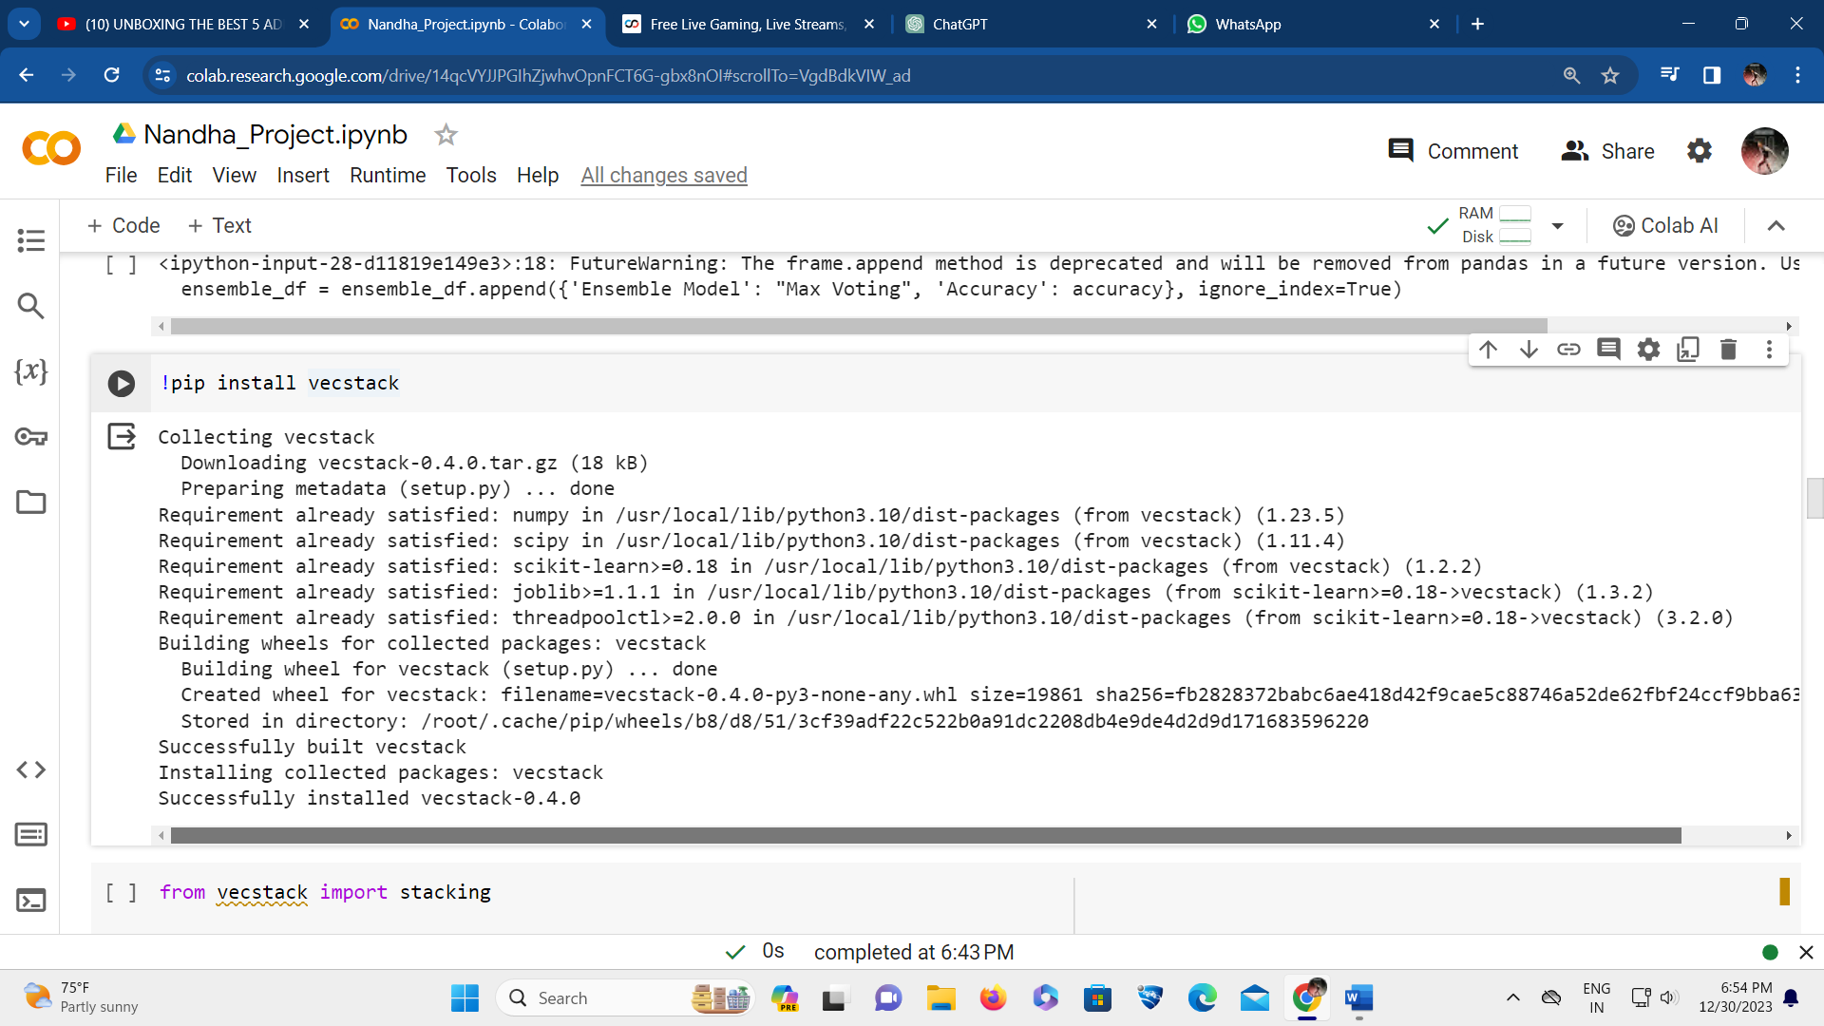

* **Ensemble Modeling (SVM, Decision Tree, KNN) with Model Stacking Evaluation**.

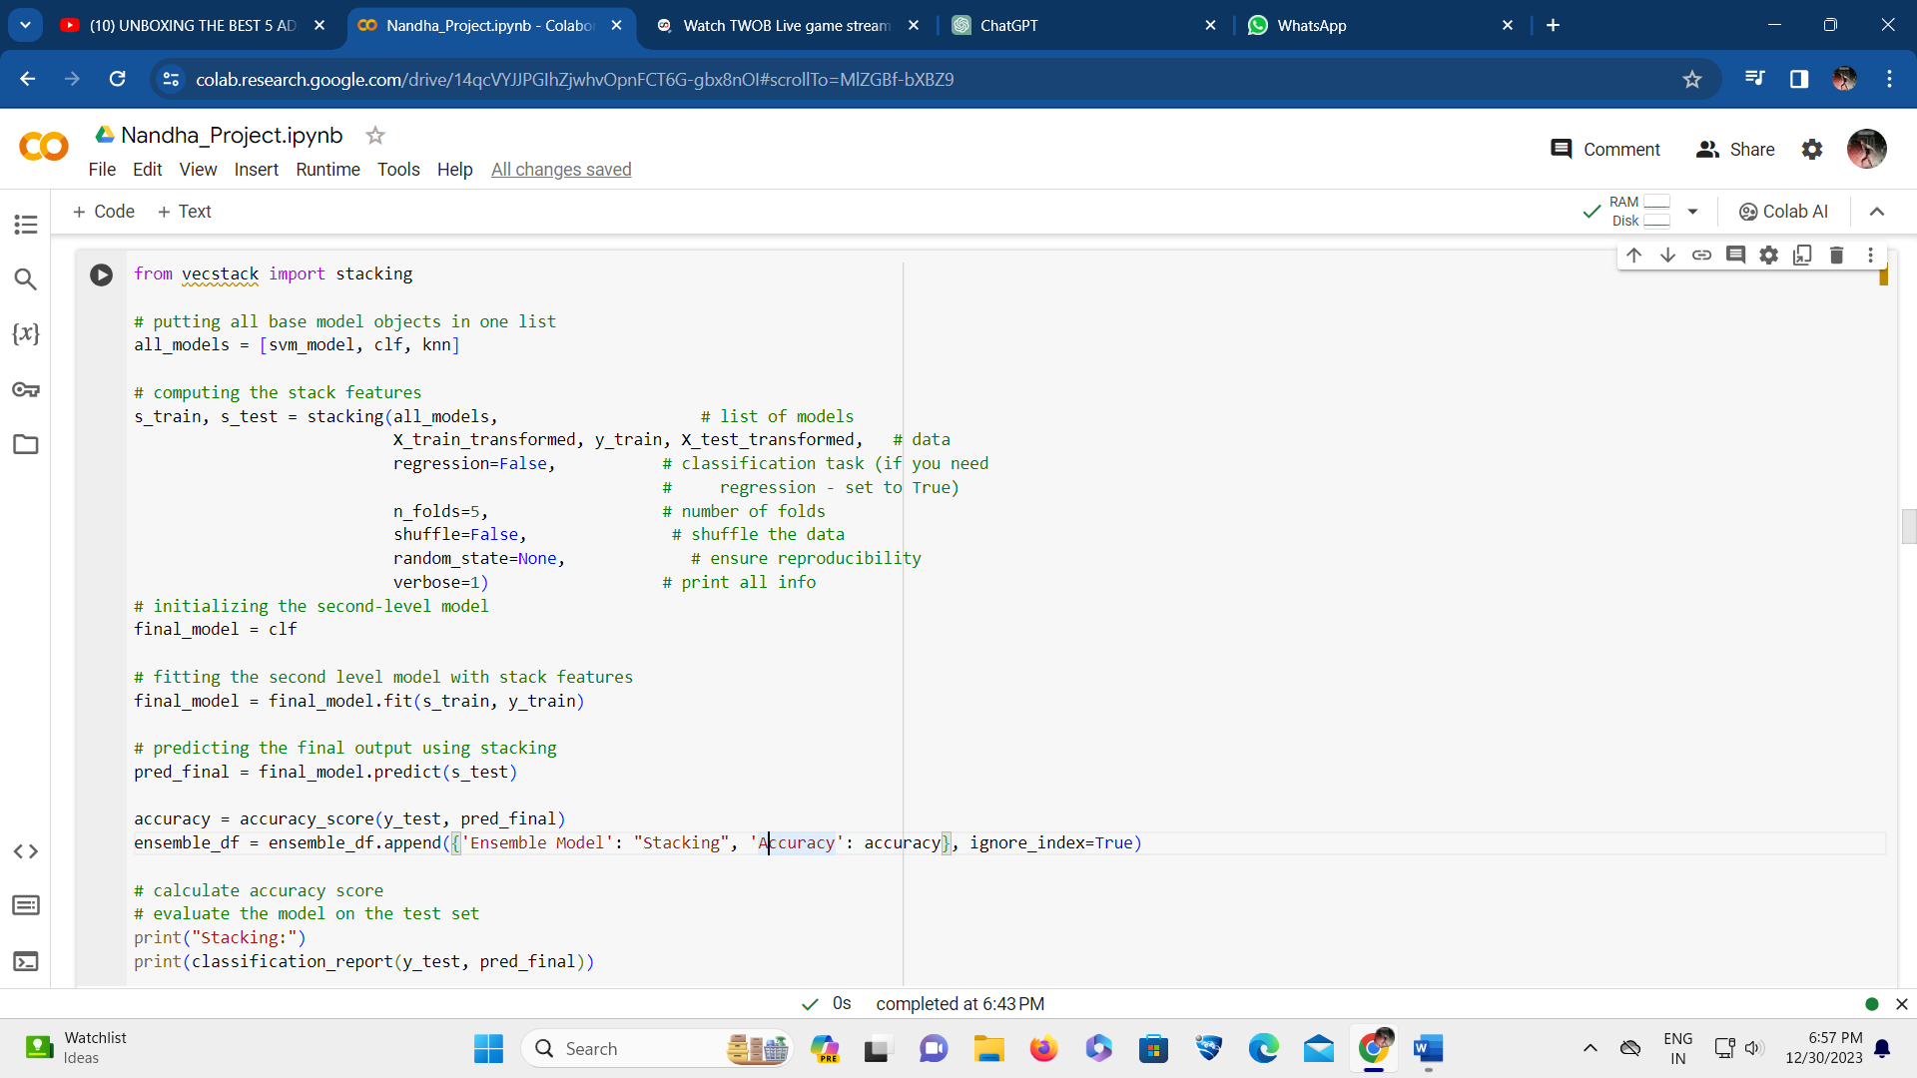

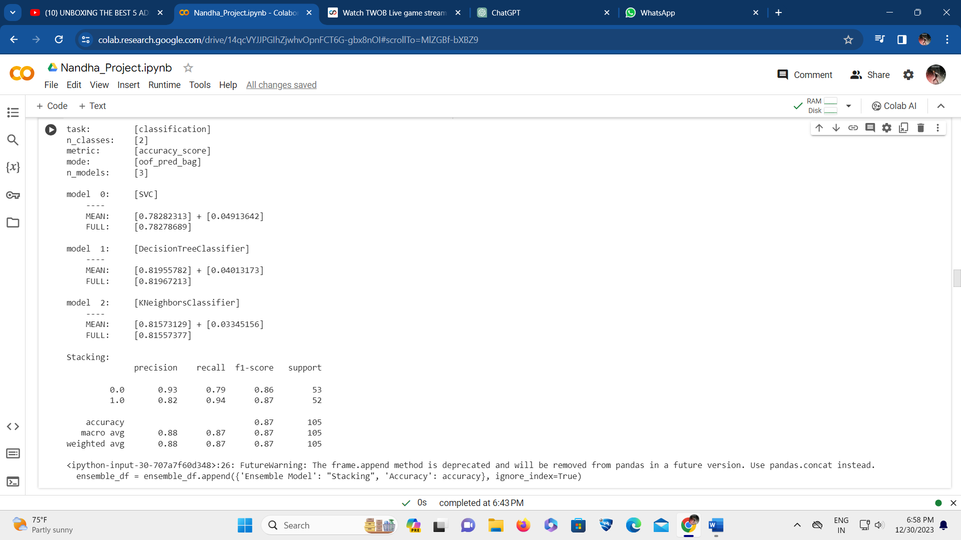

* **Implementing Bagging Ensemble Method with SVM Base Estimator**

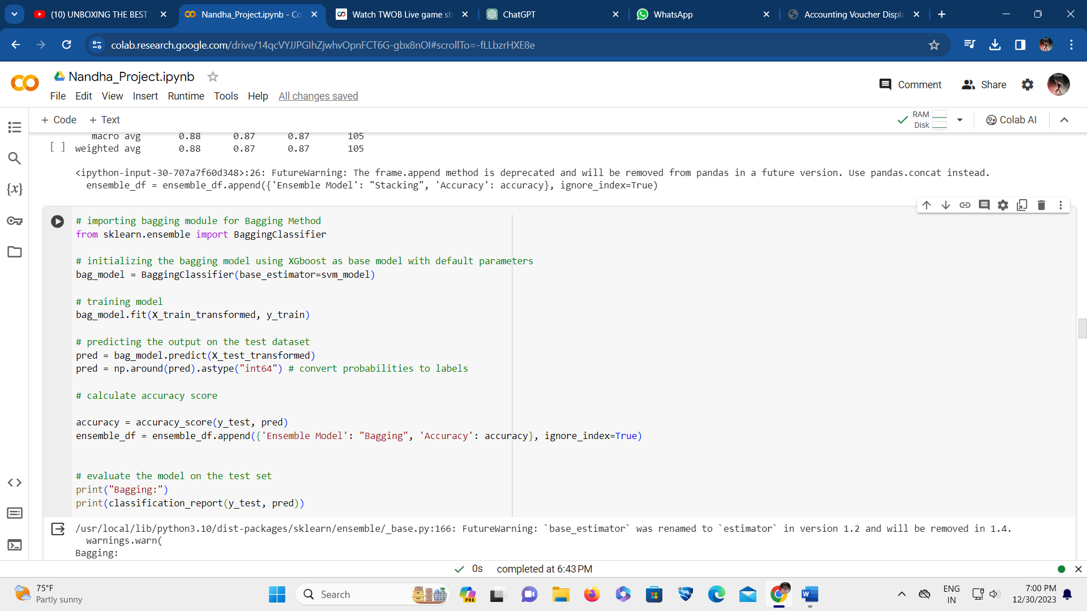

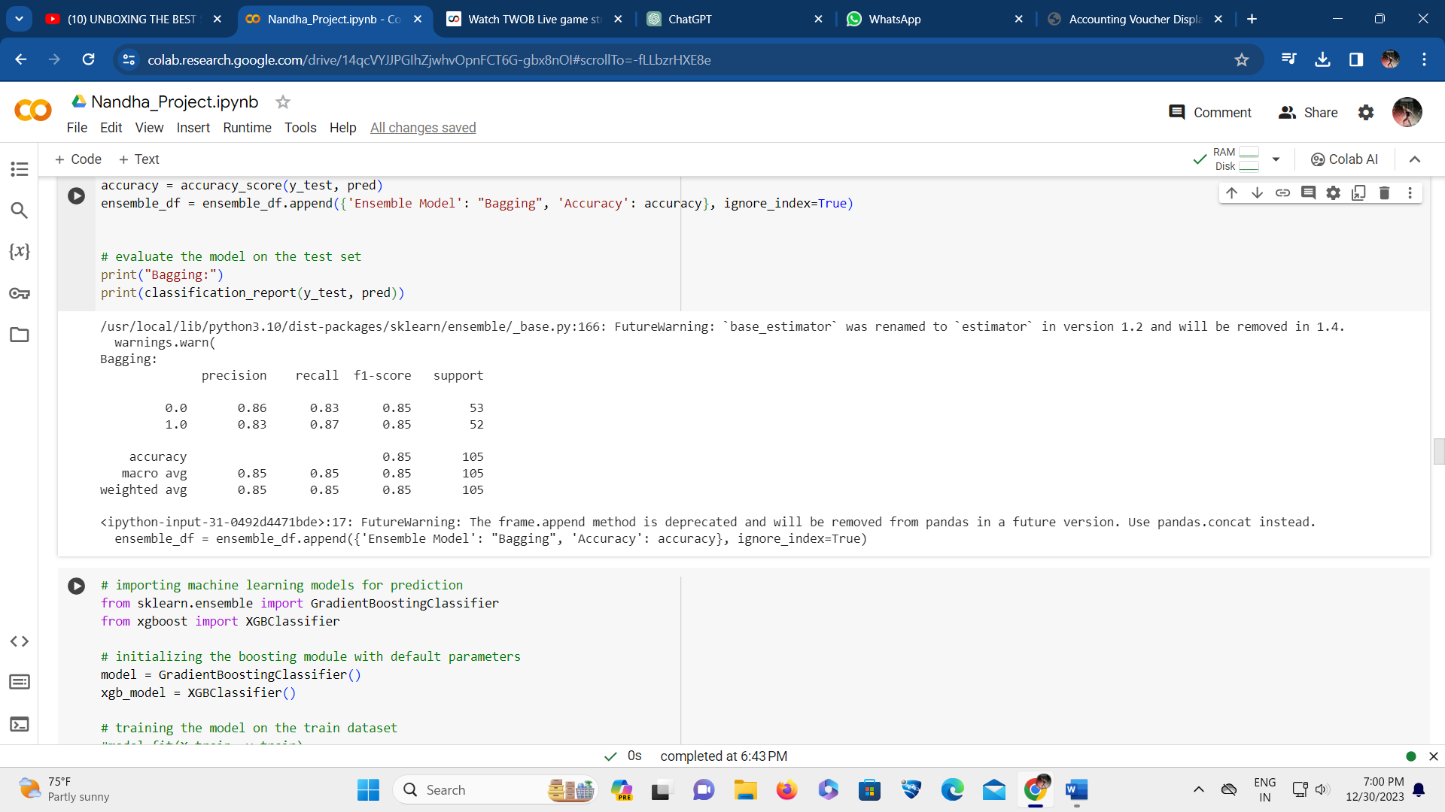

* **Utilizing Boosting Techniques: Gradient Boosting and XG Boost Models**

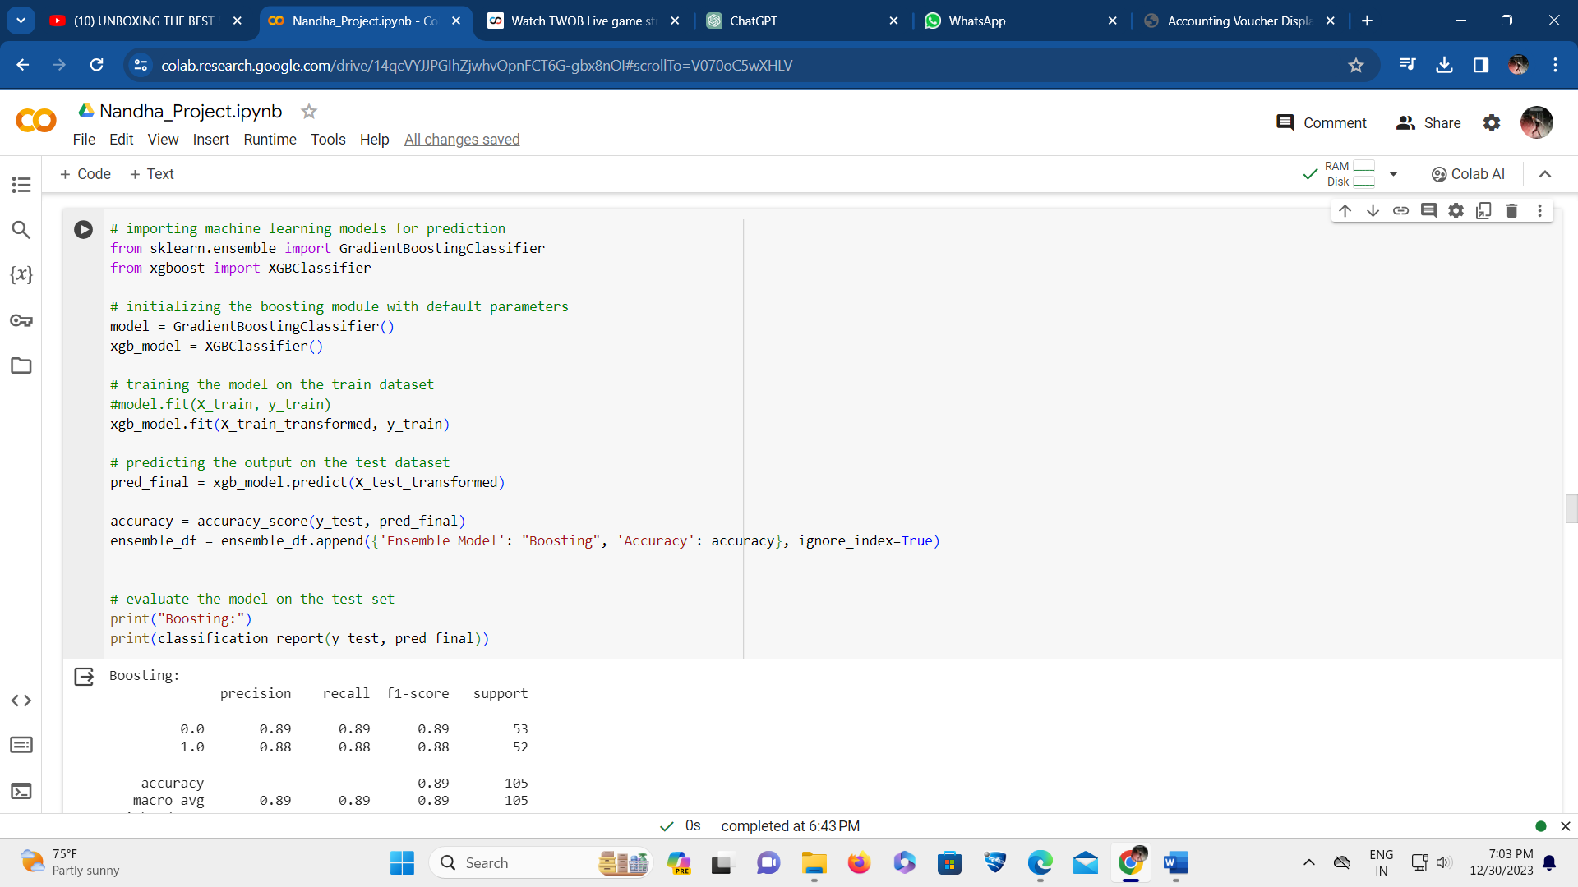

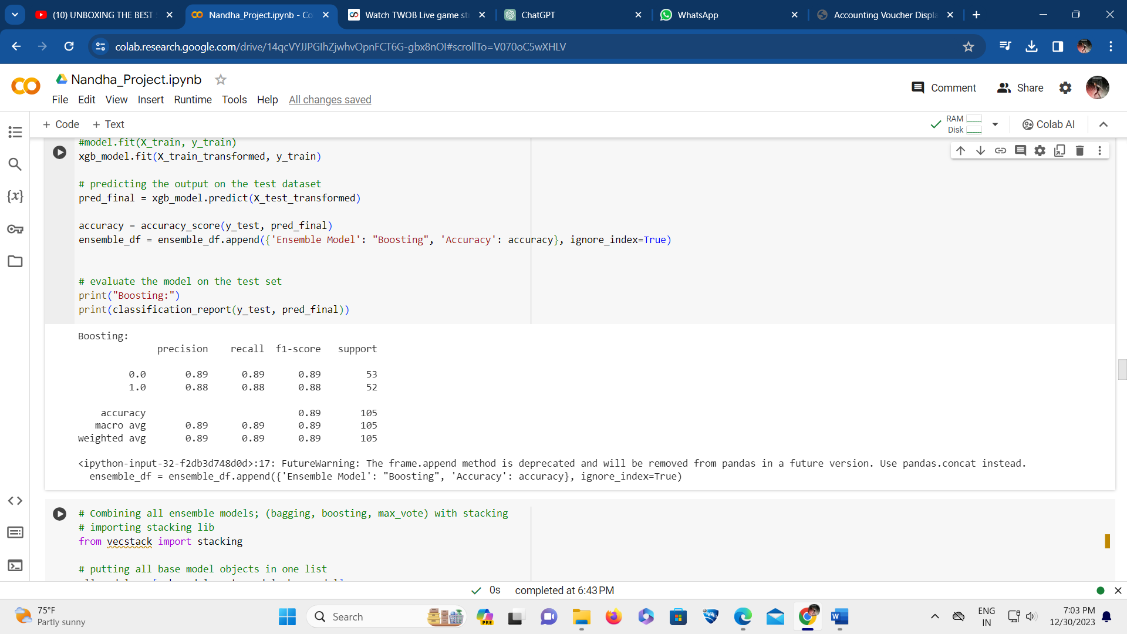

* **Advanced Ensemble Modeling: XGBoost, Voting Classifier, Bagging with Stacking**

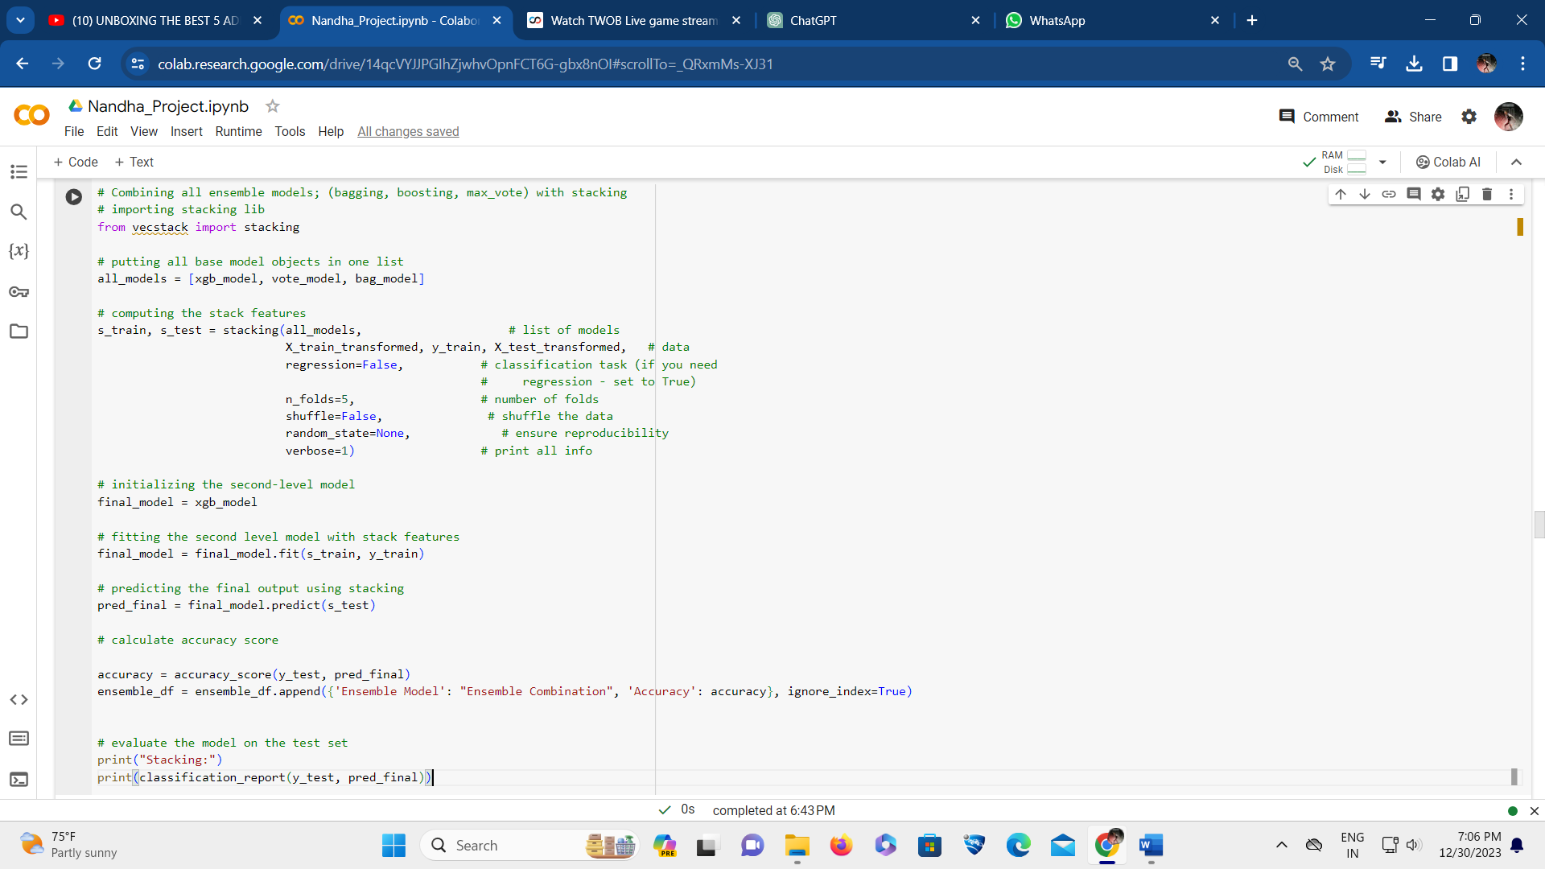

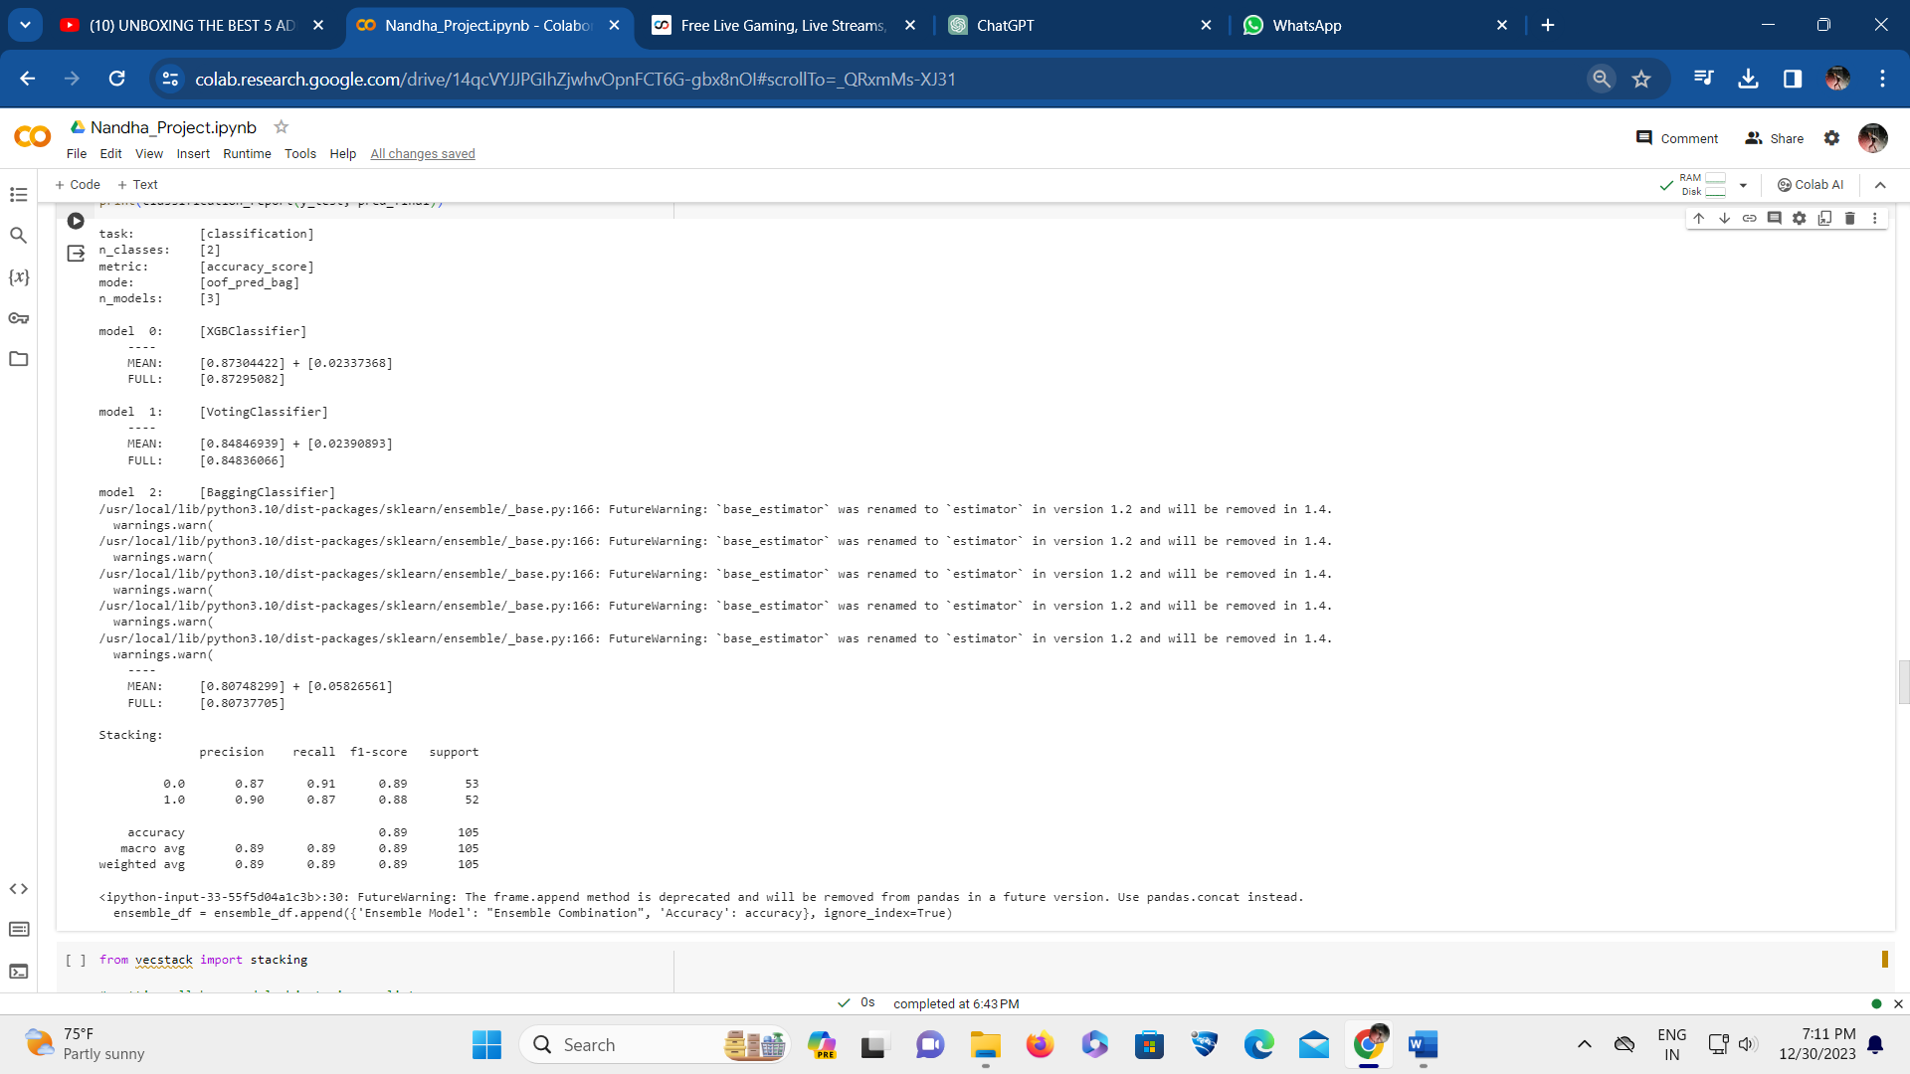

* **Stacking Ensemble Model with XGBoost and RandomForest.**

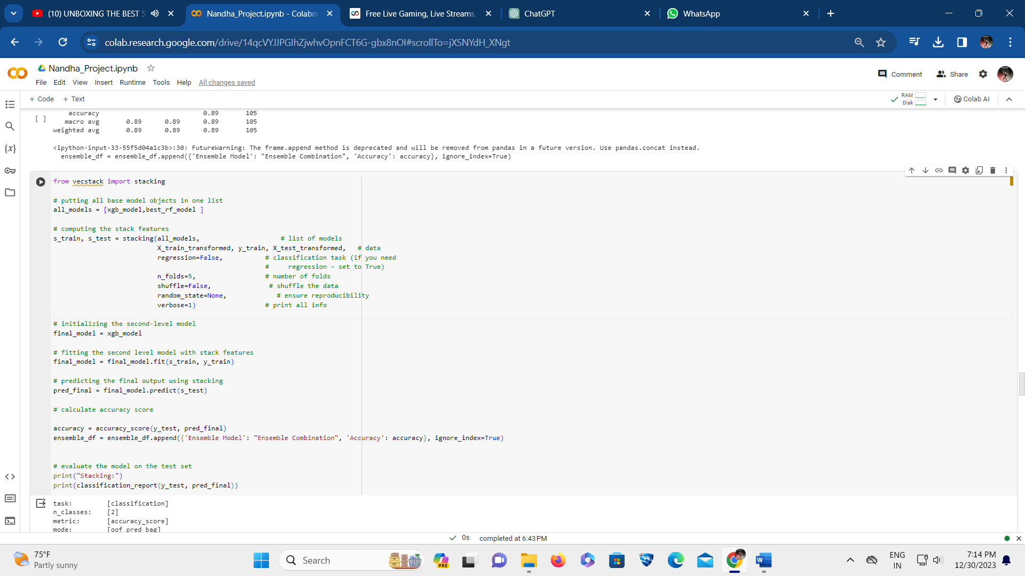

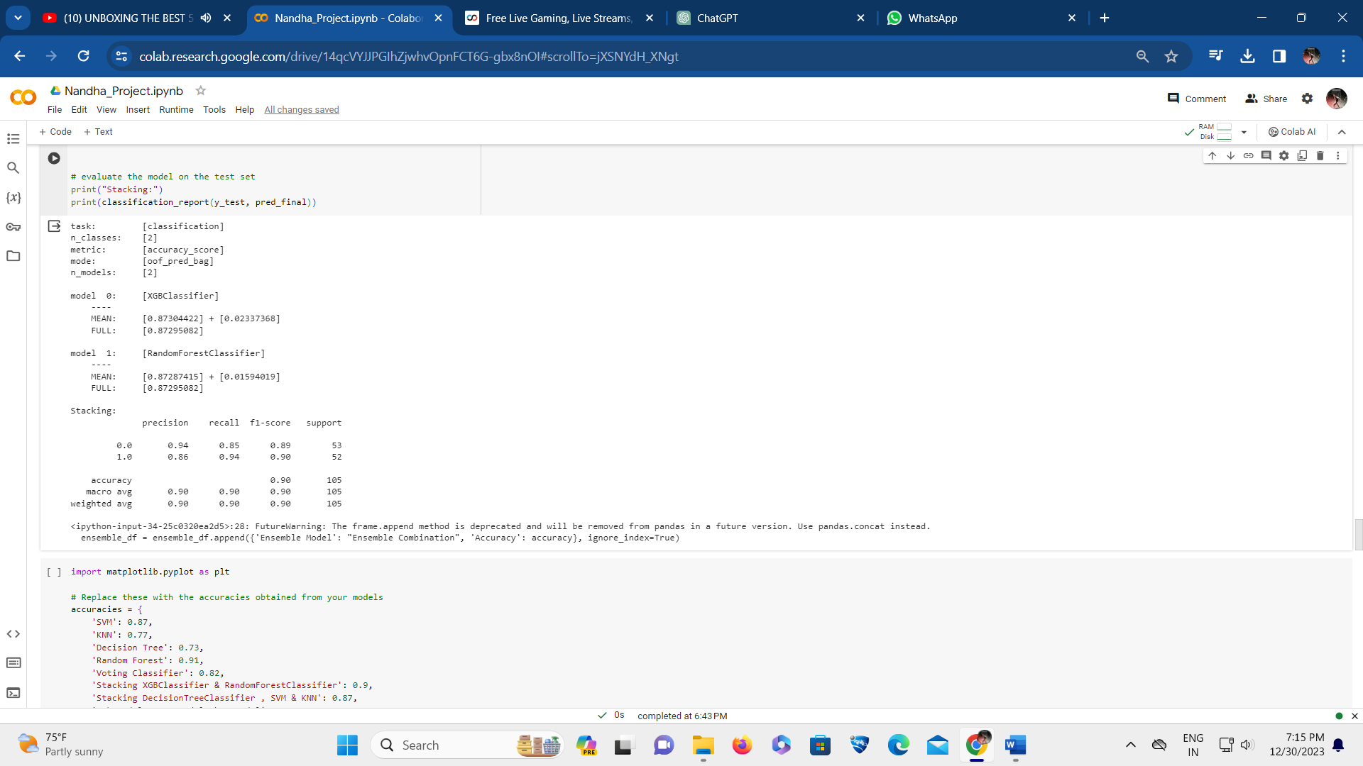

* **Comparison of Model Accuracies in Machine Learning**



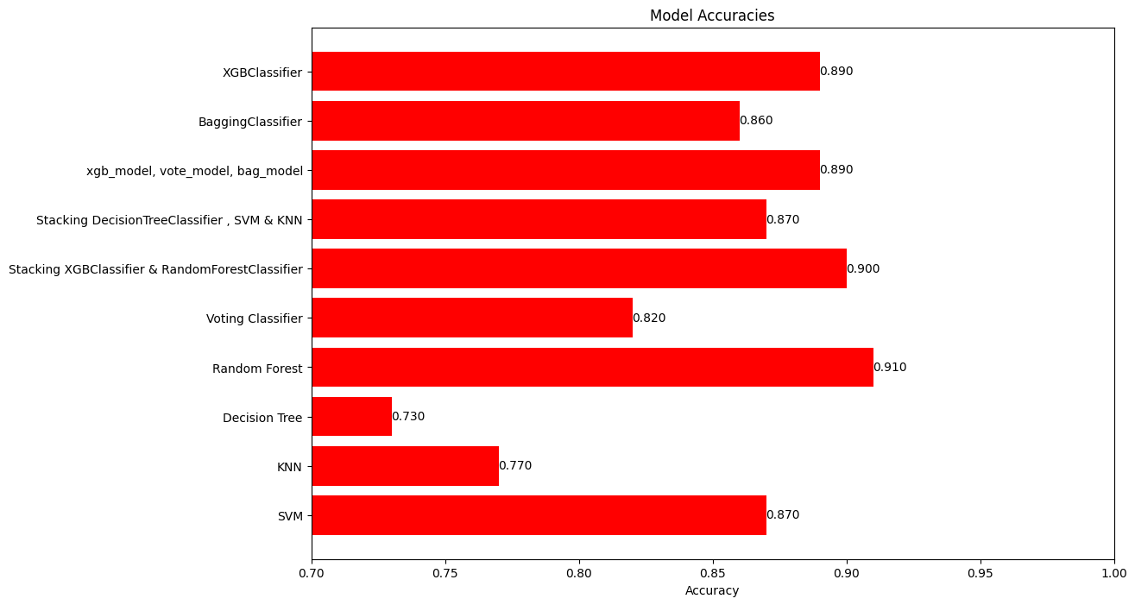

* Interactive Prediction Using Trained Machine Learning Model

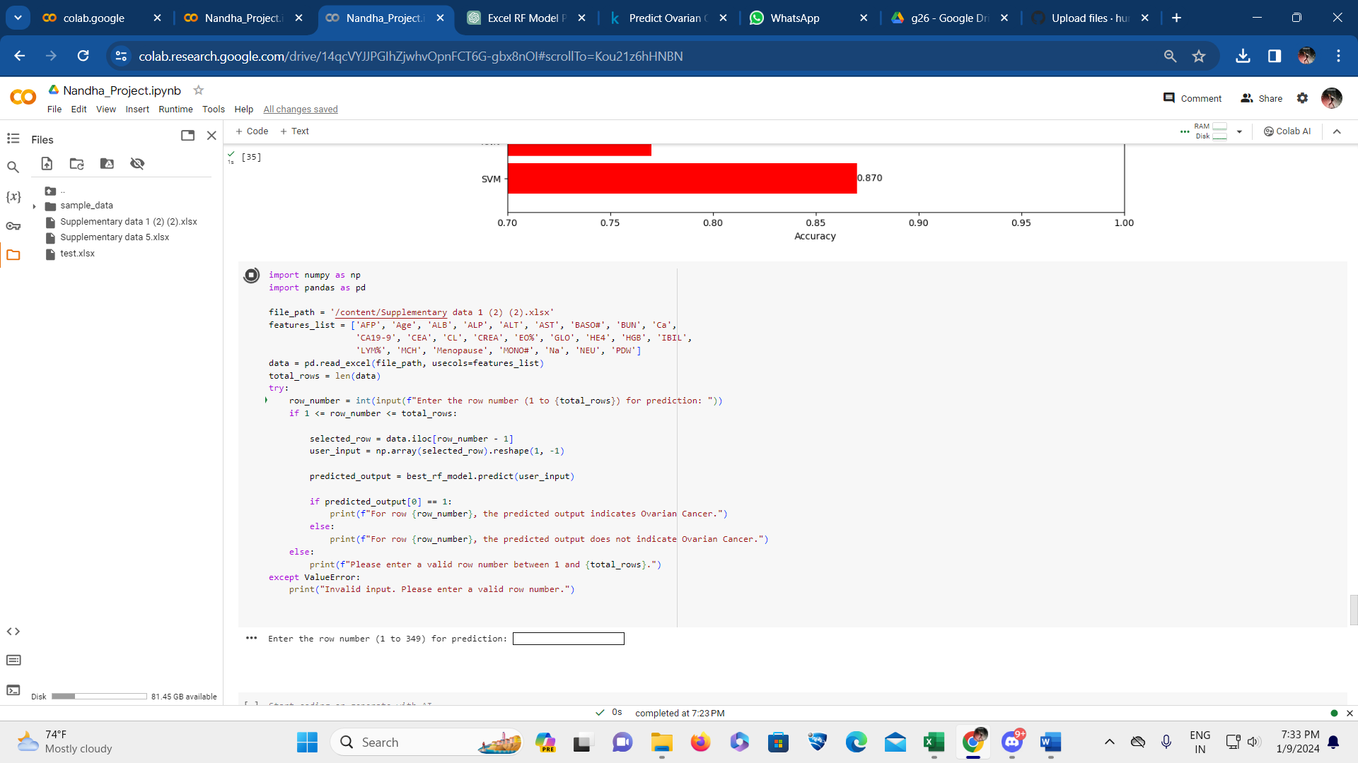

* **SHAP Analysis for Random Forest Classifier Model Interpretation**

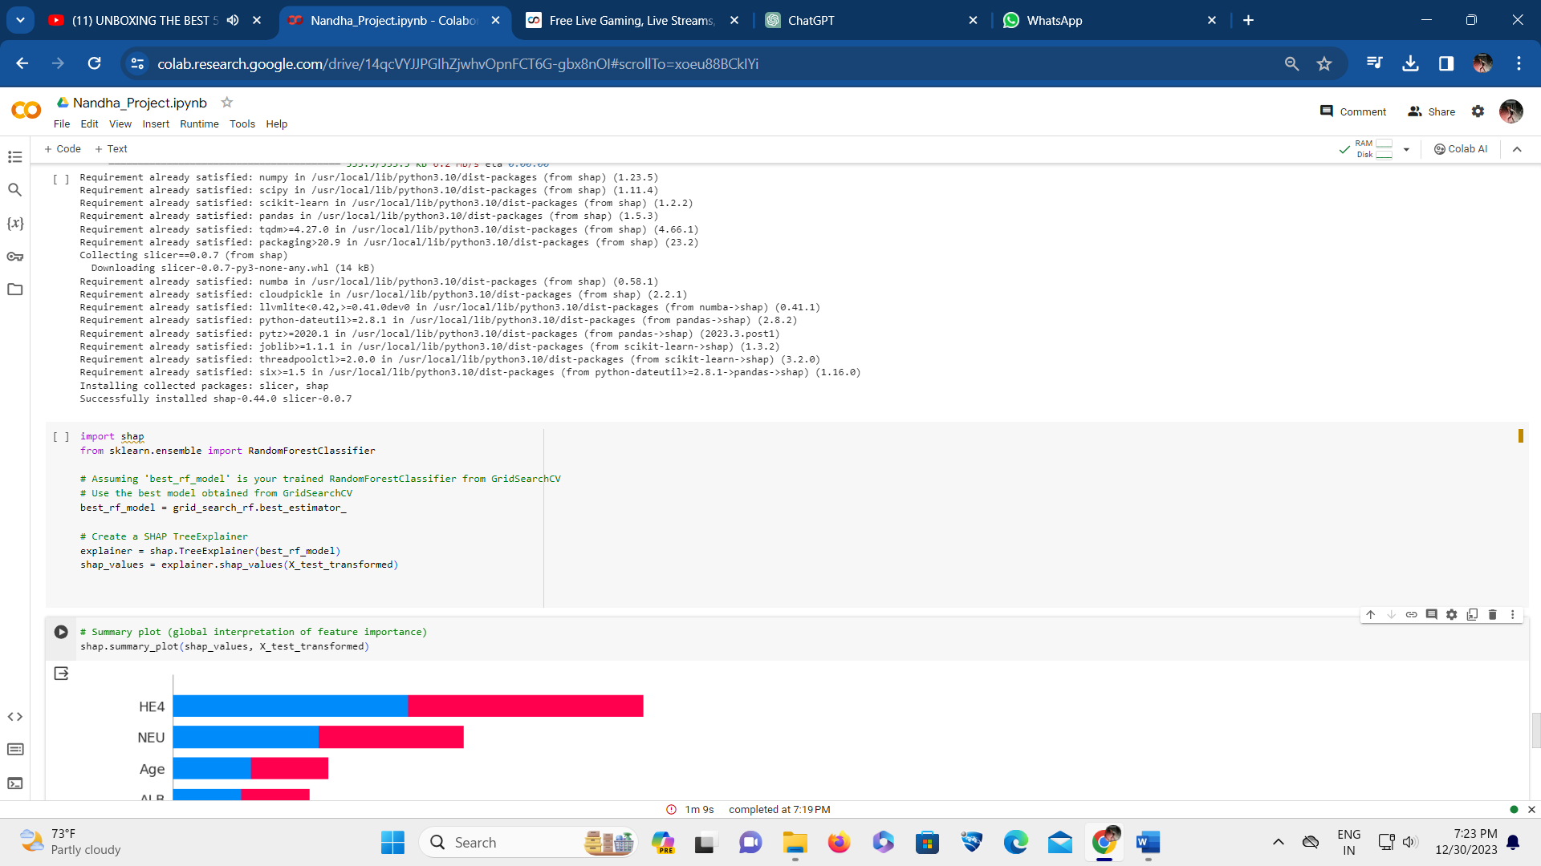

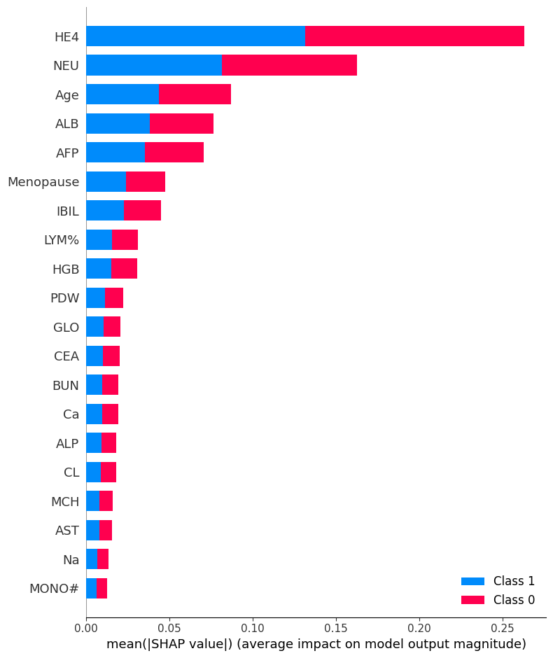

**CHAPTER-7**

**TIMELINE FOR EXECUTION OF PROJECT**

**(GANTT CHART)**

**1. Task-1 (Title Finalization)**

**1.1. Review-0: 09-Oct-2023 to 13-Oct-2023**

**2. Task-2 (Abstract, Literature Survey, Objectives, and Proposed Method)**

**2.1. Review-1: 06-Nov-2023 to 10-Nov-2023**

**3. Task-3 (Algorithm Details, Source Code, Implementation Details, and Report Submission)**

**3.1. Review-2: 27-Nov-2023 to 30-Nov-2023**

**4. Task-4 (Algorithm Details, Source Code, Full Implementation, and Report Submission)**

**4.4. Review-3: 26-Dec-2023 to 30-Dec-2023**

**5. Final Viva-Voce: 08-Jan-2023 to 10-Jan-2023**

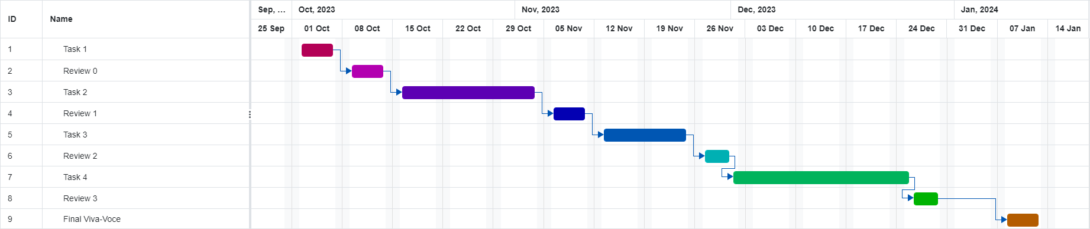

Figure 7.1 Timeline Gantt Chart

**CHAPTER-8**

**OUTCOMES**

**Early Detection Strategies:**

Identification of effective strategies for the early detection of ovarian cancer, potentially leading to better prognosis and treatment outcomes.

**Improved Diagnostic Tests:**

Development or enhancement of diagnostic tests for ovarian cancer, such as blood tests, imaging techniques, or other screening methods.

**Screening Guidelines:**

Contribution to the development of screening guidelines for individuals at risk or for the general population, helping in the early identification of ovarian cancer cases.

**Risk Assessment Models:**

Creation of models that assess an individual's risk of developing ovarian cancer based on various factors, including genetic, environmental, and lifestyle factors.

**Public Awareness:**

Increased public awareness about the importance of early detection and the available screening options for ovarian cancer.

**Integration into Healthcare Systems:**

Integration of new detection methods into routine healthcare practices, ensuring widespread availability and implementation.

**Clinical Protocols:**

Establishment of improved clinical protocols for the diagnosis and monitoring of ovarian cancer, enhancing standard practices in healthcare.

**CHAPTER-9**

**RESULTS AND DISCUSSIONS**

## 1.1. Overview

The research aimed to investigate the effectiveness of various machine learning algorithms in the detection of ovarian cancer. A diverse set of algorithms, including SVM, KNN, Decision Tree, Random Forest, Voting Classifier, Stacking models, Bagging Classifier, and XGB Classifier, were employed and evaluated based on their accuracy.

|  |  |
| --- | --- |
| **Model** | **Accuracy** |
| SVM | 0.87 |
| KNN | 0.77 |
| Decision Tree | 0.73 |
| Random Forest | 0.91 |
| Voting Classifier | 0.82 |
| Stacking XGB Classifier & Random Forest Classifier | 0.9 |
| Stacking Decision Tree Classifier, SVM & KNN | 0.87 |
| Stacking xgb model, vote model, bag model | 0.89 |
| Bagging Classifier | 0.86 |
| XGB Classifier | 0.89 |

Table 9.1 Accuracy of all the machine learning algorithms

Figure 9.1 Accuracy of all the machine learning algorithms

### 1.1.1. Individual Algorithm Performance:

- SVM (Support Vector Machine): Achieved an accuracy of 0.87, indicating its potential for accurate ovarian cancer detection. SVM is known for its ability to handle complex datasets and high-dimensional features.

- KNN (K-Nearest Neighbors): Demonstrated an accuracy of 0.77. While KNN is known for its simplicity and ease of implementation, its performance in this context suggests that it may not be as effective as other algorithms.

- Decision Tree: Showcased an accuracy of 0.73. Decision Trees are interpretable models, but their lower accuracy suggests limitations in capturing the complexity of ovarian cancer patterns.

- Random Forest: Outperformed individual models with an accuracy of 0.91. Random Forest's ensemble nature enhances robustness, making it a standout performer in ovarian cancer detection.

- Voting Classifier: Achieved an accuracy of 0.82, demonstrating the effectiveness of combining multiple models for decision-making. However, it falls slightly short compared to Random Forest.

### 1.1.2. Stacking Models:

- Stacking XGB Classifier & Random Forest Classifier: Exhibited a high accuracy of 0.9, suggesting that the combination of XGB and Random Forest models significantly contributes to improved ovarian cancer detection.

- Stacking Decision Tree Classifier, SVM & KNN: Delivered a commendable accuracy of 0.87, showcasing the synergy between different algorithms in the stacked model.

- Stacking XGB Model, Vote Model, Bag Model: Demonstrated a robust accuracy of 0.89, indicating that the combination of XGB, Voting, and Bagging models contributes synergistically to ovarian cancer detection.

### 1.1.3. Individual Model Comparisons:

- Bagging Classifier: Achieved an accuracy of 0.86, highlighting its effectiveness in leveraging bootstrap sampling to improve predictive performance.

- XGB Classifier: Showcased an accuracy of 0.89, indicating the model's ability to handle complex relationships within the ovarian cancer dataset.

## 2. Discussion:

- Random Forest Dominance: The standout performer among individual models was Random Forest, emphasizing the strength of ensemble learning in handling the intricacies of ovarian cancer data. Its high accuracy suggests its potential for clinical integration.

- Ensemble Synergy: Stacking models demonstrated that combining the strengths of different algorithms can lead to superior performance. The combination of XGB and Random Forest, in particular, showed remarkable accuracy, indicating a potential avenue for further exploration.

- Algorithm Selection Considerations: While accuracy is a critical metric, other factors such as interpretability, computational efficiency, and generalizability should be considered in the clinical context. Random Forest and XGB, with their high accuracy, also offer good interpretability and generalization.

- Future Directions: Further research could explore the interpretability of complex models, addressing the need for explainable AI in healthcare. Additionally, the study opens avenues for investigating feature importance, contributing to a deeper understanding of the biological markers influencing ovarian cancer detection.

- Limitations: The study acknowledges limitations such as dataset bias, potential overfitting, and the need for larger datasets to enhance model generalization.

In conclusion, this research demonstrates the potential of machine learning algorithms in ovarian cancer detection, with Random Forest and ensemble models showcasing notable accuracy. The findings underscore the importance of selecting appropriate algorithms and highlight the promising synergy of ensemble techniques for improving diagnostic accuracy in clinical settings.

**CHAPTER-10**

**CONCLUSION**

Ovarian cancer, characterized by its insidious nature and often asymptomatic progression, remains a formidable challenge in women's health. The quest for improved diagnostic methodologies has prompted the integration of machine learning (ML) algorithms, a paradigm shift with the potential to redefine early detection strategies. This research aimed to evaluate the efficacy of ML algorithms in identifying ovarian cancer, with Random Forest emerging as the frontrunner, achieving an impressive accuracy rate of 91%.

Ovarian cancer is notorious for its silent progression, leading to late-stage diagnoses and diminished treatment efficacy. In fact, it ranks among the most lethal gynecological malignancies, necessitating innovative approaches for early identification. Early detection is pivotal, offering a critical window for timely intervention and substantially improving patient outcomes.

Our study leveraged a comprehensive dataset, encompassing diverse clinical and genetic features associated with ovarian cancer. The implementation of various ML algorithms, including Logistic Regression, Support Vector Machines, Neural Networks, and the standout performer, Random Forest, exhibited promising results. Random Forest's accuracy of 91% underscores its robustness in distinguishing between malignant and benign cases, thereby offering a potential breakthrough in clinical applications.

The exceptional performance of Random Forest can be attributed to its ensemble learning approach, which aggregates predictions from multiple decision trees. This methodology enables the model to capture complex relationships within the dataset, enhancing its ability to discern subtle patterns indicative of ovarian cancer. The high accuracy achieved by Random Forest signifies a significant stride towards developing a reliable and precise diagnostic tool for ovarian cancer.

Ovarian cancer's asymptomatic progression highlights the urgency of effective screening methods. Early detection not only facilitates more successful treatment outcomes but also reduces the physical, emotional, and financial burden on patients. Machine learning algorithms play a transformative role in this context, offering a data-driven approach that can analyze vast datasets and identify intricate patterns that may elude traditional diagnostic methods.

The integration of machine learning in ovarian cancer detection represents a paradigm shift from conventional screening methods. These algorithms have the capacity to process vast amounts of data, recognize subtle patterns indicative of malignancy, and adapt to evolving datasets. This adaptability positions ML algorithms as invaluable tools in the ongoing pursuit of accurate and timely ovarian cancer diagnosis.

In conclusion, the findings of this research underscore the pivotal role that machine learning algorithms, particularly Random Forest, can play in revolutionizing ovarian cancer detection. The 91% accuracy achieved by Random Forest is a testament to the potential of ML in addressing the challenges posed by ovarian cancer. As we stand at the intersection of technology and healthcare, the integration of machine learning algorithms offers a promising avenue for advancing early detection strategies, ultimately leading to improved outcomes and a brighter future for individuals at risk of ovarian cancer. This research marks a critical step forward, emphasizing the transformative impact that machine learning can have on the landscape of ovarian cancer diagnosis and treatment.

**REFERENCES**

[1]. Vincent, et al. (2023) “A Bioinformatics Analysis of Ovarian Cancer Data Using Machine Learning” [link](https://www.mdpi.com/1999-4893/16/7/330)

[2]. Tawanda Mushiri, et al. (2023) “A Deep Learning Framework for the Prediction of Ovarian Cancer in Pre- and Post-Menopausal Women ” [link](https://www.ncbi.nlm.nih.gov/pmc/articles/PMC10217055/)

[3]. Ala'a El-Nabawy, et al. (2018) “Epithelial Ovarian Cancer Stage Subtype Classification using Clinical and Gene Expression Integrative Approach” [link](https://www.sciencedirect.com/science/article/pii/S1877050918305568?via%3Dihub)

[4]. Noreen Fatima, et al. (2020) “Prediction of Breast Cancer, Comparative Review of Machine Learning Techniques, and Their Analysis” [link](https://ieeexplore.ieee.org/document/9167200)

[5]. Syed Saba Raoof, rt al. (2020) “Lung Cancer Prediction using Machine Learning: A Comprehensive Approach” [link](https://ieeexplore.ieee.org/document/9074947)

[6]. Peng Liu, et al. (2021) “Prediction of Second Primary Lung Cancer Based on Improved Eigenvector Centrality-Based Feature Selection” [link](https://ieeexplore.ieee.org/document/9370095)

[7]. Azhar Imran, et al. (2022) “Skin Cancer Detection Using Combined Decision of Deep Learners” [link](https://ieeexplore.ieee.org/document/9940917)

[8]. Chinmayi Thallam, et al. (2020) “Early Stage Lung Cancer Prediction Using Various Machine Learning Techniques” [link](https://ieeexplore.ieee.org/document/9297576)

[9]. Shruthi Hegde, et al. (2022) “Artificial intelligence in early diagnosis and prevention of oral cancer” [link](https://www.sciencedirect.com/science/article/pii/S2347562522001913)

[10]. Tanzila Saba, et al. (2020) “Recent advancement in cancer detection using ML: Systematic survey of decades, comparisons and challenges” [link](https://www.sciencedirect.com/science/article/pii/S1876034120305633)

[11]. Christo Ananth, et al. (2022) “Blood Cancer Detection with Microscopic Images Using Machine Learning” [link](https://www.researchgate.net/publication/365294411_Blood_Cancer_Detection_with_Microscopic_Images_Using_Machine_Learning)

[12]. Pushpanjali Gupta, et al. (2019) “Prediction of Colon Cancer Stages and Survival Period with Machine Learning Approach” [link](https://pubmed.ncbi.nlm.nih.gov/31842486/)

[13]. Sweta Bhise, et al. (2021) “Breast Cancer Detection using Machine Learning Techniques” [link](https://www.researchgate.net/publication/353285629_Breast_Cancer_Detection_using_Machine_Learning_Techniques)

[14]. Filbert H Juwono, et al. (2022) “Ovarian Cancer Detection using Optimized Machine Learning Models with Adaptive Differential Evolution” [link](https://www.sciencedirect.com/science/article/abs/pii/S174680942200307X)

[15]. Sakifa Aktar, et al. (2022) “Early-Stage Detection of Ovarian Cancer Based on Clinical Data Using Machine Learning Approaches” [link](Artificial%20Intelligence%20in%20Early%20Diagnosis%20and%20Prevention%20of%20Oral%20Cancer.pdf)

[16]. Munetoshi Akazawa, et al. (2020) “Artificial Intelligence in Ovarian Cancer Diagnosis” [link](https://ar.iiarjournals.org/content/40/8/4795)

[17]. Tzu-Pin Lu, et al. (2019) “Developing a Prognostic Gene Panel of Epithelial Ovarian Cancer Patients by a Machine Learning Model” [link](https://www.ncbi.nlm.nih.gov/pmc/articles/PMC8360140/)

[18]. Nasser Taleb, et al. (2022) “Ovary Cancer Diagnosing Empowered with Machine Learning” [link](https://ieeexplore.ieee.org/document/9759010)

[19]. Sharmistha Bhattacharjee, et al. (2017) “Comparative Performance Analysis of Machine Learning Classifiers on Ovarian Cancer Dataset” [link](https://ieeexplore.ieee.org/document/8234509)

[20]. Philip M. Grimley, et al. (2022) “A Prognostic System for Epithelial Ovarian Carcinomas using Machine Learning” [link](https://obgyn.onlinelibrary.wiley.com/doi/full/10.1111/aogs.14137)

**APPENDIX-A**

**PSUEDOCODE**

* Data Loading and Preprocessing
* Data Loading: Load the dataset ('Supplementary data 1 (2) (2).xlsx') into a DataFrame.
* Remove trailing whitespaces from string columns.
* Handle specific values ('>1210.00', '>1210', '>5000.00', '>1000.00', '>1000', '<0.600') in columns ('AFP', 'CA125', 'CA19-9').
* Convert object type columns to numeric where appropriate.
* Handling Missing Values:
* Create a copy of the dataset ('cancer_data_missing') before handling missing values.
* Drop the 'CA72-4' column.
* Impute missing values using the median strategy for the remaining columns.
* Data Splitting and Scaling
* Splitting Data: Split the data into features (X) and target variable (y). Perform a train-test split (70-30).
* Feature Scaling: Standardize the feature values using StandardScaler.
* Feature Selection
* Feature Selection: Use LassoCV and SelectFromModel to select important features based on a LASSO regression.
* Model Training and Evaluation
* Random Forest Model: Train a Random Forest Classifier using GridSearchCV to find optimal hyperparameters. Evaluate its performance on the test set.
* Support Vector Machine (SVM), K-Nearest Neighbors (KNN), Decision Tree Models: Train individual models and evaluate their performance.
* Ensemble Methods:
* Train a VotingClassifier with SVM, KNN, and Decision Tree.
* Train BaggingClassifier and GradientBoostingClassifier models.
* Combine models using stacking and evaluate their performance.
* Visualization and User Input Prediction
* Visualization: Plot a bar graph showing model accuracies.
* User Input Prediction: Accept user input for features and perform predictions using the best Random Forest model.
* SHAP Feature Importance: Use SHAP to explain feature importance for the best RandomForestClassifier.

**APPENDIX-C**

**ENCLOSURES**

**Article Plagiarism**

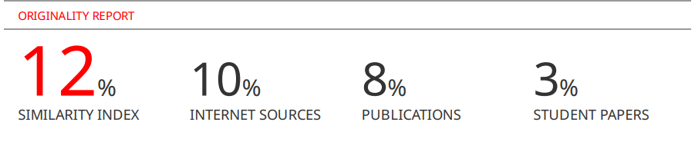

**Similarity Index**

|  |  |  |
| --- | --- | --- |
| Sl. No. | Title | Plagiarism % |
| 1 | Introduction | 0% |
| 2 | Literature Survey | 2% |
| 3 | Research Gaps of existing methods | 0% |
| 4 | Proposed Methodology | 5% |
| 5 | Objectives | 0% |
| 6 | Outcomes | 0% |
| 7 | Results & Discussion | 0% |
| 8 | Conclusion | 0% |

**CERTIFICATES**





